Growth Rate and Decay Rate

Growth Rate
# Source: AI Source: Provided by: [Data Path: Persons Table -> ID Column: 1, Name_En Column: Motasem Essam] -> From: [ChatGPT] on [7/15/2026]
Growth Rate measures how quickly a quantity increases over time or between two measurements. It is usually expressed as a percentage and describes the relative increase compared to the original value.
Growth rates are widely used in arithmetic, algebra, finance, economics, business, population studies, biology, engineering, computer science, and statistics.

Definition
# Source: AI Source: Provided by: [Data Path: Persons Table -> ID Column: 1, Name_En Column: Motasem Essam] -> From: [ChatGPT] on [7/15/2026]
A Growth Rate is the percentage increase of a quantity or rate over a specified period.
If
- $V_{1}$is the original value,
- $V_{2}$is the new value,
then the growth rate is
$$\boxed{\text{Growth Rate}=\frac{V_{2}-V_{1}}{V_{1}}×100\%}$$
where
$$V_{2}>V_{1}.$$

Growth Rate Formula
# Source: AI Source: Provided by: [Data Path: Persons Table -> ID Column: 1, Name_En Column: Motasem Essam] -> From: [ChatGPT] on [7/15/2026]
$$\boxed{\text{Growth Rate}=\frac{\text{Increase}}{\text{Original Value}}×100\%}$$
Since
$$\text{Increase}=V_{2}-V_{1},$$
the formula becomes
$$\boxed{\text{Growth Rate}=\frac{V_{2}-V_{1}}{V_{1}}×100\%}$$

Finding the New Value
# Source: AI Source: Provided by: [Data Path: Persons Table -> ID Column: 1, Name_En Column: Motasem Essam] -> From: [ChatGPT] on [7/15/2026]
If the growth rate is known,
$$\boxed{V_{2}=V_{1}\left(1 + \frac{r}{100}\right)}$$
where
- $r$is the growth rate (%).

Growth Factor
# Source: AI Source: Provided by: [Data Path: Persons Table -> ID Column: 1, Name_En Column: Motasem Essam] -> From: [ChatGPT] on [7/15/2026]
Instead of using a percentage, growth can be represented by a growth factor.
$$\boxed{\text{Growth Factor}=1+\frac{r}{100}}$$
Examples:
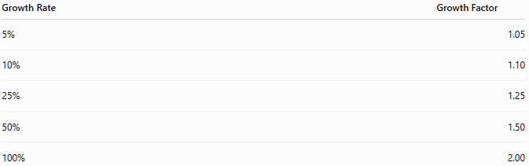
Growth Rate | Growth Factor
5% | 1.05
10% | 1.10
25% | 1.25
50% | 1.50
100% | 2.00

Types of Growth
# Source: AI Source: Provided by: [Data Path: Persons Table -> ID Column: 1, Name_En Column: Motasem Essam] -> From: [ChatGPT] on [7/15/2026]
- Population growth
- Financial growth
- Salary growth
- Production growth
- Business growth
- Investment growth
- Sales growth
- Technology growth
- Data growth
- Biological growth

Examples
# Source: AI Source: Provided by: [Data Path: Persons Table -> ID Column: 1, Name_En Column: Motasem Essam] -> From: [ChatGPT] on [7/15/2026]
Example 1 – Salary
Original salary:
$$\$4000$$
New salary:
$$\$4600$$
Growth rate:
$$\frac{4600-4000}{4000}×100=15\%$$

Example 2 – Population
Original population:
$$20,000$$
New population:
$$21,200$$
Growth rate:
$$\frac{1200}{20000}×100=6\%$$

Example 3 – Business Revenue
Revenue increases from
$$\$80,000$$
to
$$\$92,000.$$
Growth rate:
$$\frac{12000}{80000}×100=15\%$$

Example 4 – Production
Factory output:
$$500$$
to
$$650$$
items.
Growth rate:
$$\frac{150}{500}×100=30\%$$

Example 5 – Internet Users
Users increase from
$$40,000$$
to
$$50,000.$$
Growth rate:
$$25\%$$

Example 6 – Tree Height
Tree height:
$$2.5$$
m to
$$3.0$$
m.
Growth rate:
$$20\%$$

Growth Rate Table
# Source: AI Source: Provided by: [Data Path: Persons Table -> ID Column: 1, Name_En Column: Motasem Essam] -> From: [ChatGPT] on [7/15/2026]
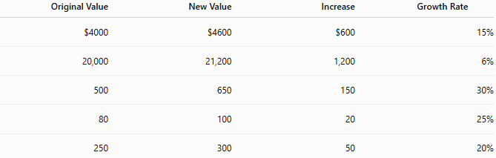
Original Value | New Value | Increase | Growth Rate
$4000 | $4600 | $600 | 15%
20,000 | 21,200 | 1,200 | 6%
500 | 650 | 150 | 30%
80 | 100 | 20 | 25%
250 | 300 | 50 | 20%

Applications
# Source: AI Source: Provided by: [Data Path: Persons Table -> ID Column: 1, Name_En Column: Motasem Essam] -> From: [ChatGPT] on [7/15/2026]
Growth rates are used in:
- Arithmetic
- Algebra
- Finance
- Economics
- Statistics
- Business
- Engineering
- Biology
- Computer Science
- Data Science

Real-Life Applications
# Source: AI Source: Provided by: [Data Path: Persons Table -> ID Column: 1, Name_En Column: Motasem Essam] -> From: [ChatGPT] on [7/15/2026]
Growth rates are used in:
- Salary increases
- Business revenue
- Population growth
- Company profits
- Investment returns
- Inflation analysis
- Stock prices
- Manufacturing output
- Agricultural production
- Website traffic

Real-Life Examples
# Source: AI Source: Provided by: [Data Path: Persons Table -> ID Column: 1, Name_En Column: Motasem Essam] -> From: [ChatGPT] on [7/15/2026]
1. Employee Salary
Salary grows from
$$\$3200$$
to
$$\$3520.$$
Growth rate:
$$10\%$$

2. Company Sales
Sales increase from
$$\$2 000 000$$
to
$$\$2 400 000.$$
Growth rate:
$$20\%$$

3. Population
Population grows from
$$50,000$$
to
$$53,000.$$
Growth rate:
$$6\%$$

4. Manufacturing
Production increases from
$$900$$
to
$$1080$$
units.
Growth rate:
$$20\%$$

5. Website Visitors
Visitors increase from
$$10,000$$
to
$$12,500.$$
Growth rate:
$$25\%$$

6. Savings Account
Balance increases from
$$\$5000$$
to
$$\$5250.$$
Growth rate:
$$5\%$$

Common Mistakes
# Source: AI Source: Provided by: [Data Path: Persons Table -> ID Column: 1, Name_En Column: Motasem Essam] -> From: [ChatGPT] on [7/15/2026]
- Dividing by the new value instead of the original value.
- Forgetting to multiply by
$$100\%.$$
- Confusing growth rate with absolute growth.
- Using growth rate when the value actually decreased.
- Ignoring the time period associated with the growth.

Key Points
# Source: AI Source: Provided by: [Data Path: Persons Table -> ID Column: 1, Name_En Column: Motasem Essam] -> From: [ChatGPT] on [7/15/2026]
- Growth rate measures relative increase.
- It is expressed as a percentage.
- It is based on the original value.
- Positive growth indicates an increase.
- Growth factors simplify repeated calculations.

Growth Rate vs. Growth Factor
# Source: AI Source: Provided by: [Data Path: Persons Table -> ID Column: 1, Name_En Column: Motasem Essam] -> From: [ChatGPT] on [7/15/2026]
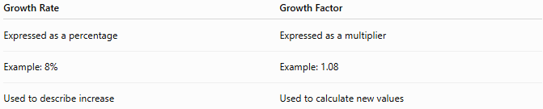
Growth Rate | Growth Factor
Expressed as a percentage | Expressed as a multiplier
Example: 8% | Example: 1.08
Used to describe increase | Used to calculate new values

Growth Rate vs. Percentage Increase
# Source: AI Source: Provided by: [Data Path: Persons Table -> ID Column: 1, Name_En Column: Motasem Essam] -> From: [ChatGPT] on [7/15/2026]
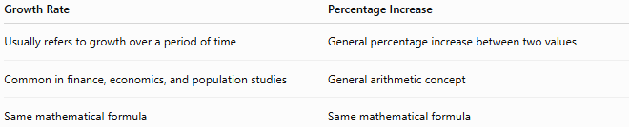
Growth Rate | Percentage Increase
Usually refers to growth over a period of time | General percentage increase between two values
Common in finance, economics, and population studies | General arithmetic concept
Same mathematical formula | Same mathematical formula

Growth Rate vs. Percentage Rate Change
# Source: AI Source: Provided by: [Data Path: Persons Table -> ID Column: 1, Name_En Column: Motasem Essam] -> From: [ChatGPT] on [7/15/2026]
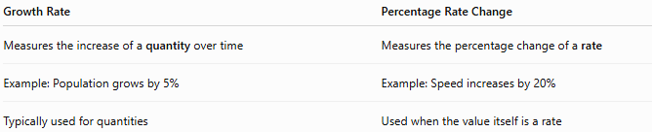
Growth Rate | Percentage Rate Change
Measures the increase of a quantity over time | Measures the percentage change of a rate
Example: Population grows by 5% | Example: Speed increases by 20%
Typically used for quantities | Used when the value itself is a rate

Growth Rate vs. Decline Rate
# Source: AI Source: Provided by: [Data Path: Persons Table -> ID Column: 1, Name_En Column: Motasem Essam] -> From: [ChatGPT] on [7/15/2026]
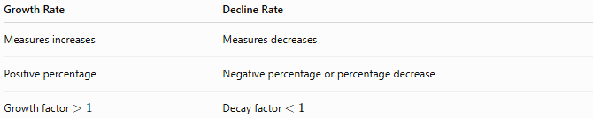
Growth Rate | Decline Rate
Measures increases | Measures decreases
Positive percentage | Negative percentage or percentage decrease
Growth factor $>1$ | Decay factor $<1$

Conclusion
# Source: AI Source: Provided by: [Data Path: Persons Table -> ID Column: 1, Name_En Column: Motasem Essam] -> From: [ChatGPT] on [7/15/2026]
A Growth Rate measures the percentage increase of a quantity relative to its original value. It is calculated by
$$\frac{V_{2}-V_{1}}{V_{1}}×100\%,$$
and is commonly represented either as a percentage or as a growth factor for calculations involving repeated growth. Growth rates are essential in mathematics and are extensively applied in finance, economics, business, science, engineering, population studies, and many other fields to analyze and predict how quantities increase over time.

Growth Factor
# Source: AI Source: Provided by: [Data Path: Persons Table -> ID Column: 1, Name_En Column: Motasem Essam] -> From: [ChatGPT] on [7/15/2026]
A Growth Factor is a multiplier that represents how much a quantity grows after applying a growth rate. Instead of working directly with percentages, the growth factor provides a convenient way to calculate new values after growth.
Growth factors are widely used in arithmetic, algebra, finance, economics, engineering, population studies, statistics, computer science, and exponential growth models.

Definition
# Source: AI Source: Provided by: [Data Path: Persons Table -> ID Column: 1, Name_En Column: Motasem Essam] -> From: [ChatGPT] on [7/15/2026]
A Growth Factor is the number by which the original value is multiplied to obtain the new value after growth.
If the growth rate is
$$r\%$$
then the growth factor is
$$\boxed{1+\frac{r}{100}}$$

Growth Factor Formula
# Source: AI Source: Provided by: [Data Path: Persons Table -> ID Column: 1, Name_En Column: Motasem Essam] -> From: [ChatGPT] on [7/15/2026]
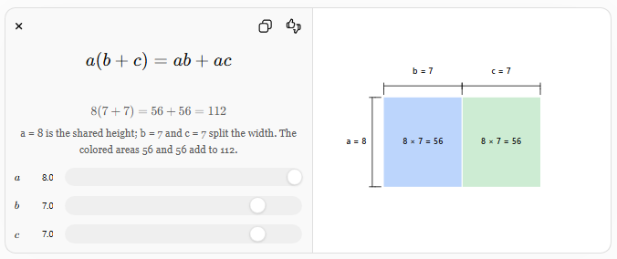
The growth factor is
$$\boxed{\text{Growth Factor}=1+\frac{r}{100}}$$
where
- $r$= growth rate (%).

New Value Formula
# Source: AI Source: Provided by: [Data Path: Persons Table -> ID Column: 1, Name_En Column: Motasem Essam] -> From: [ChatGPT] on [7/15/2026]
Once the growth factor is known,
$$\boxed{\text{New Value}=\text{Original Value}×\text{Growth Factor}}$$
or
$$\boxed{V_{2}=V_{1}\left(1 + \frac{r}{100}\right)}$$

Finding the Growth Rate from the Growth Factor
If the growth factor is known,
$$\boxed{\text{Growth Rate}=(\text{Growth Factor}-1)×100\%}$$

Growth Factor Table
# Source: AI Source: Provided by: [Data Path: Persons Table -> ID Column: 1, Name_En Column: Motasem Essam] -> From: [ChatGPT] on [7/15/2026]
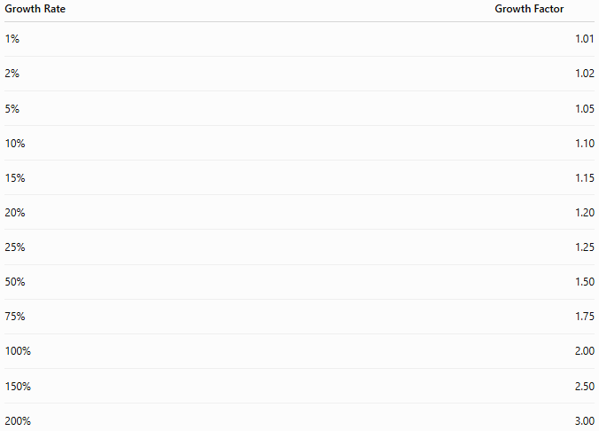
Growth Rate | Growth Factor
1% | 1.01
2% | 1.02
5% | 1.05
10% | 1.10
15% | 1.15
20% | 1.20
25% | 1.25
50% | 1.50
75% | 1.75
100% | 2.00
150% | 2.50
200% | 3.00

Examples
# Source: AI Source: Provided by: [Data Path: Persons Table -> ID Column: 1, Name_En Column: Motasem Essam] -> From: [ChatGPT] on [7/15/2026]
Example 1 – Salary Increase
Original salary:
$$\$4000$$
Growth rate:
$$10\%$$
Growth factor:
$$1+\frac{10}{100}=1.10$$
New salary:
$$4000×1.10=4400$$

Example 2 – Population Growth
Population:
$$50,000$$
Growth rate:
$$6\%$$
Growth factor:
$$1.06$$
New population:
$$50,000×1.06=53,000$$

Example 3 – Business Revenue
Revenue:
$$\$120,000$$
Growth rate:
$$15\%$$
Growth factor:
$$1.15$$
New revenue:
$$138,000$$

Example 4 – Investment
Investment:
$$\$8000$$
Growth rate:
$$8\%$$
Growth factor:
$$1.08$$
New value:
$$8640$$

Example 5 – Production
Factory output:
$$500$$
Growth rate:
$$25\%$$
Growth factor:
$$1.25$$
New production:
$$625$$

Example 6 – Tree Height
Original height:
$$4$$
m
Growth rate:
$$20\%$$
Growth factor:
$$1.20$$
New height:
$$4.8$$
m

Growth Factor Table with Calculations
# Source: AI Source: Provided by: [Data Path: Persons Table -> ID Column: 1, Name_En Column: Motasem Essam] -> From: [ChatGPT] on [7/15/2026]
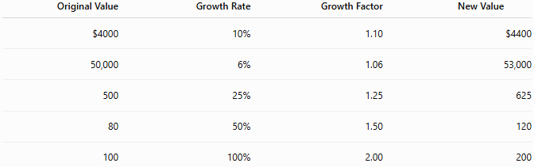
Original Value | Growth Rate | Growth Factor | New Value
$4000 | 10% | 1.10 | $4400
50,000 | 6% | 1.06 | 53,000
500 | 25% | 1.25 | 625
80 | 50% | 1.50 | 120
100 | 100% | 2.00 | 200

Multiple Growth Periods
# Source: AI Source: Provided by: [Data Path: Persons Table -> ID Column: 1, Name_En Column: Motasem Essam] -> From: [ChatGPT] on [7/15/2026]
If growth occurs repeatedly over
$$n$$
periods,
$$\boxed{V=V_{0}(\text{Growth Factor})^{n}}$$
or
$$\boxed{V=V_{0}{\left(1 + \frac{r}{100}\right)}^{n}}$$

Example
# Source: AI Source: Provided by: [Data Path: Persons Table -> ID Column: 1, Name_En Column: Motasem Essam] -> From: [ChatGPT] on [7/15/2026]
Initial investment:
$$\$1000$$
Growth rate:
$$5\%$$
Growth factor:
$$1.05$$
After
3
years:
$$1000(1.05)^{3}=1157.63$$

Applications
# Source: AI Source: Provided by: [Data Path: Persons Table -> ID Column: 1, Name_En Column: Motasem Essam] -> From: [ChatGPT] on [7/15/2026]
Growth factors are used in:
- Arithmetic
- Algebra
- Finance
- Economics
- Engineering
- Statistics
- Biology
- Computer Science
- Population Studies
- Data Science

Real-Life Applications
# Source: AI Source: Provided by: [Data Path: Persons Table -> ID Column: 1, Name_En Column: Motasem Essam] -> From: [ChatGPT] on [7/15/2026]
Growth factors are used in:
- Compound interest
- Population forecasting
- Business sales projections
- Inflation calculations
- Investment analysis
- Manufacturing growth
- Website traffic growth
- Biological population growth
- Data storage growth
- Economic forecasting

Real-Life Examples
# Source: AI Source: Provided by: [Data Path: Persons Table -> ID Column: 1, Name_En Column: Motasem Essam] -> From: [ChatGPT] on [7/15/2026]
1. Bank Account
Interest:
5%
Growth factor:
$$1.05$$

2. Population
Growth:
3%
Growth factor:
$$1.03$$

3. Company Revenue
Growth:
12%
Growth factor:
$$1.12$$

4. Manufacturing
Production grows
20%.
Growth factor:
$$1.20$$

5. Investments
Annual return:
8%
Growth factor:
$$1.08$$

6. Website Visitors
Visitor growth:
40%
Growth factor:
$$1.40$$

Common Mistakes
# Source: AI Source: Provided by: [Data Path: Persons Table -> ID Column: 1, Name_En Column: Motasem Essam] -> From: [ChatGPT] on [7/15/2026]
- Using
$$0.10$$
instead of
$$1.10.$$
- Forgetting to convert the percentage to decimal form.
- Adding the percentage after multiplication instead of using the growth factor.
- Confusing the growth factor with the growth rate.
- Using a growth factor for a decreasing quantity (a decay factor should be used instead).

Key Points
# Source: AI Source: Provided by: [Data Path: Persons Table -> ID Column: 1, Name_En Column: Motasem Essam] -> From: [ChatGPT] on [7/15/2026]
- A growth factor is a multiplier.
- It is always greater than 1 for positive growth.
- Multiply the original value by the growth factor to obtain the new value.
- Repeated growth uses exponents.
- Growth factors simplify repeated calculations.

Growth Factor vs. Growth Rate
# Source: AI Source: Provided by: [Data Path: Persons Table -> ID Column: 1, Name_En Column: Motasem Essam] -> From: [ChatGPT] on [7/15/2026]
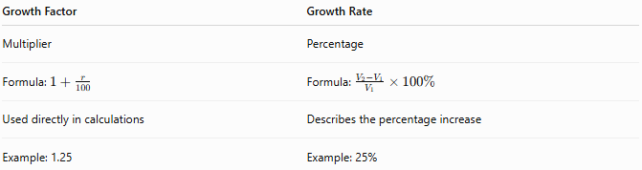
Growth Factor | Growth Rate
Multiplier | Percentage
Formula: $1+\frac{r}{100}$ | Formula: $\frac{V_{2}-V_{1}}{V_{1}}×100\%$
Used directly in calculations | Describes the percentage increase
Example: 1.25 | Example: 25%

Growth Factor vs. Decay Factor
# Source: AI Source: Provided by: [Data Path: Persons Table -> ID Column: 1, Name_En Column: Motasem Essam] -> From: [ChatGPT] on [7/15/2026]
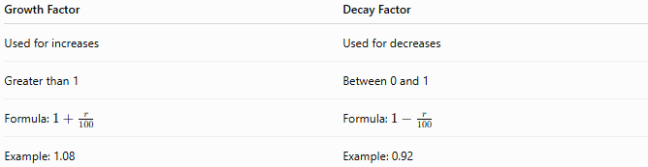
Growth Factor | Decay Factor
Used for increases | Used for decreases
Greater than 1 | Between 0 and 1
Formula: $1+\frac{r}{100}$ | Formula: $1-\frac{r}{100}$
Example: 1.08 | Example: 0.92

Growth Factor vs. Compound Growth
# Source: AI Source: Provided by: [Data Path: Persons Table -> ID Column: 1, Name_En Column: Motasem Essam] -> From: [ChatGPT] on [7/15/2026]
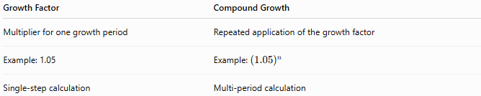
Growth Factor | Compound Growth
Multiplier for one growth period | Repeated application of the growth factor
Example: 1.05 | Example: ${\left(1.05\right)}^{n}$
Single-step calculation | Multi-period calculation

Conclusion
# Source: AI Source: Provided by: [Data Path: Persons Table -> ID Column: 1, Name_En Column: Motasem Essam] -> From: [ChatGPT] on [7/15/2026]
A Growth Factor is the multiplier used to calculate the new value of a quantity after growth. It is computed by
$$1+\frac{r}{100},$$
where $r$is the growth rate expressed as a percentage. The new value is found by multiplying the original value by the growth factor, and repeated growth is modeled using powers of the growth factor. Growth factors are fundamental in mathematics and are widely used in finance, economics, population studies, engineering, business, and scientific modeling because they provide a simple and efficient way to represent and calculate growth over time.

Simple Growth
# Source: AI Source: Provided by: [Data Path: Persons Table -> ID Column: 1, Name_En Column: Motasem Essam] -> From: [ChatGPT] on [7/15/2026]
Simple Growth is the process in which a quantity increases by a fixed amount each period, where the increase is always calculated from the original value, not the current value.
Unlike compound growth, simple growth does not earn growth on previous growth. Therefore, the amount added during each period remains constant.
Simple growth is widely used in arithmetic, algebra, finance, economics, engineering, business, and introductory mathematics.

Definition
# Source: AI Source: Provided by: [Data Path: Persons Table -> ID Column: 1, Name_En Column: Motasem Essam] -> From: [ChatGPT] on [7/15/2026]
Simple Growth is repeated growth where the increase in each period is based only on the original value.
If a quantity grows by
$$r\%$$
per period, then each period adds the same amount:
$$\boxed{\text{Increase per Period}=V_{0}×\frac{r}{100}}$$
where
- $V_{0}$= original value.

Simple Growth Formula
# Source: AI Source: Provided by: [Data Path: Persons Table -> ID Column: 1, Name_En Column: Motasem Essam] -> From: [ChatGPT] on [7/15/2026]
The final value after
$$n$$
periods is
$$\boxed{V=V_{0}\left(1 + \frac{rn}{100}\right)}$$
where
- $V_{0}$= original value
- $V$= final value
- $r$= growth rate (% per period)
- $n$= number of periods

Total Growth
# Source: AI Source: Provided by: [Data Path: Persons Table -> ID Column: 1, Name_En Column: Motasem Essam] -> From: [ChatGPT] on [7/15/2026]
The total increase is
$$\boxed{\text{Total Growth}=V_{0}×\frac{rn}{100}}$$

How Simple Growth Works
# Source: AI Source: Provided by: [Data Path: Persons Table -> ID Column: 1, Name_En Column: Motasem Essam] -> From: [ChatGPT] on [7/15/2026]
Suppose
- Initial value = 100
- Growth rate = 10%
Increase every period:
$$100×10\%=10$$
Values become:
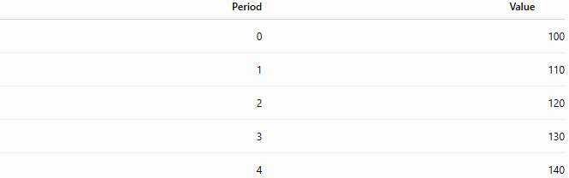
Period | Value
0 | 100
1 | 110
2 | 120
3 | 130
4 | 140
Notice that 10 is added every period.

Examples
# Source: AI Source: Provided by: [Data Path: Persons Table -> ID Column: 1, Name_En Column: Motasem Essam] -> From: [ChatGPT] on [7/15/2026]
Example 1 – Savings
Initial savings:
$$\$1000$$
Growth:
$$5\%$$
Time:
$$3$$
years
Increase each year:
$$1000×5\%=50$$
Total increase:
$$50×3=150$$
Final value:
$$1150$$

Example 2 – Salary
Original salary:
$$\$4000$$
Annual growth:
$$10\%$$
Years:
$$4$$
Increase each year:
$$400$$
Total increase:
$$1600$$
Final salary:
$$5600$$

Example 3 – Investment
Investment:
$$\$5000$$
Growth:
$$8\%$$
Years:
$$5$$
Increase each year:
$$400$$
Total increase:
$$2000$$
Final value:
$$7000$$

Example 4 – Production
Production:
$$500$$
Growth:
$$20\%$$
Periods:
$$3$$
Increase each period:
$$100$$
Final production:
$$800$$

Example 5 – Tree Height
Height:
$$2$$
m
Growth:
$$15\%$$
Years:
$$4$$
Increase each year:
$$0.3$$
m
Final height:
$$3.2$$
m

Example 6 – Website Visitors
Visitors:
$$10,000$$
Growth:
$$5\%$$
Months:
$$6$$
Increase each month:
$$500$$
Final visitors:
$$13,000$$

Simple Growth Table
# Source: AI Source: Provided by: [Data Path: Persons Table -> ID Column: 1, Name_En Column: Motasem Essam] -> From: [ChatGPT] on [7/15/2026]
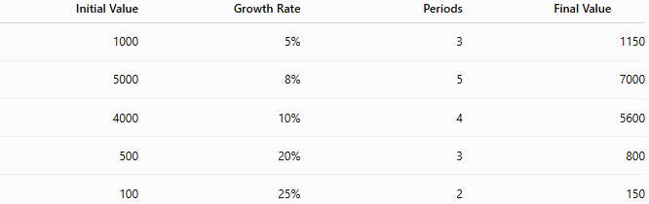
Initial Value | Growth Rate | Periods | Final Value
1000 | 5% | 3 | 1150
5000 | 8% | 5 | 7000
4000 | 10% | 4 | 5600
500 | 20% | 3 | 800
100 | 25% | 2 | 150

Applications
# Source: AI Source: Provided by: [Data Path: Persons Table -> ID Column: 1, Name_En Column: Motasem Essam] -> From: [ChatGPT] on [7/15/2026]
Simple growth is used in:
- Arithmetic
- Algebra
- Finance
- Economics
- Engineering
- Business
- Education
- Budget planning
- Manufacturing
- Basic forecasting

Real-Life Applications
# Source: AI Source: Provided by: [Data Path: Persons Table -> ID Column: 1, Name_En Column: Motasem Essam] -> From: [ChatGPT] on [7/15/2026]
Simple growth is used in:
- Simple interest loans
- Fixed annual bonuses
- Regular salary increments
- Budget forecasting
- Manufacturing targets
- Fixed production increases
- Inventory planning
- Agricultural estimates
- Educational examples
- Linear population models

Real-Life Examples
# Source: AI Source: Provided by: [Data Path: Persons Table -> ID Column: 1, Name_En Column: Motasem Essam] -> From: [ChatGPT] on [7/15/2026]
1. Bank Account
A savings account earns simple interest of 5% per year on the original deposit.

2. Employee Salary
An employee receives an annual raise equal to 10% of the original salary every year.

3. Factory Production
A factory increases production by the same number of units each year.

4. Tree Growth
A tree grows by the same height every year.

5. Inventory
A warehouse adds the same quantity of products every month.

6. Budget
A department receives the same annual budget increase based on the original budget.

Common Mistakes
# Source: AI Source: Provided by: [Data Path: Persons Table -> ID Column: 1, Name_En Column: Motasem Essam] -> From: [ChatGPT] on [7/15/2026]
- Confusing simple growth with compound growth.
- Applying the percentage to the current value instead of the original value.
- Using exponents in simple growth calculations.
- Forgetting that the increase per period remains constant.
- Assuming simple growth accelerates over time.

Key Points
# Source: AI Source: Provided by: [Data Path: Persons Table -> ID Column: 1, Name_En Column: Motasem Essam] -> From: [ChatGPT] on [7/15/2026]
- Simple growth is based on the original value.
- The increase is the same every period.
- Growth follows a linear pattern.
- No growth is earned on previous growth.
- Simple growth is commonly used in simple interest calculations.

Simple Growth vs. Compound Growth
# Source: AI Source: Provided by: [Data Path: Persons Table -> ID Column: 1, Name_En Column: Motasem Essam] -> From: [ChatGPT] on [7/15/2026]
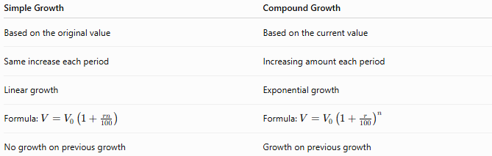
Simple Growth | Compound Growth
Based on the original value | Based on the current value
Same increase each period | Increasing amount each period
Linear growth | Exponential growth
Formula: $V=V_{0}\left(1 + \frac{rn}{100}\right)$ | Formula: $V=V_{0}{\left(1 + \frac{r}{100}\right)}^{n}$
No growth on previous growth | Growth on previous growth

Simple Growth vs. Linear Growth
# Source: AI Source: Provided by: [Data Path: Persons Table -> ID Column: 1, Name_En Column: Motasem Essam] -> From: [ChatGPT] on [7/15/2026]
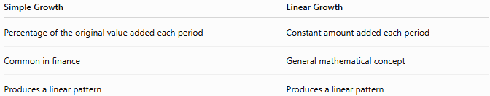
Simple Growth | Linear Growth
Percentage of the original value added each period | Constant amount added each period
Common in finance | General mathematical concept
Produces a linear pattern | Produces a linear pattern

Simple Growth vs. Simple Interest
# Source: AI Source: Provided by: [Data Path: Persons Table -> ID Column: 1, Name_En Column: Motasem Essam] -> From: [ChatGPT] on [7/15/2026]
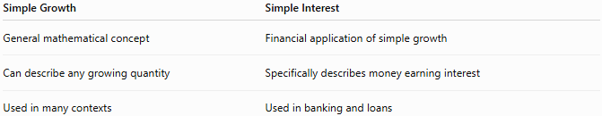
Simple Growth | Simple Interest
General mathematical concept | Financial application of simple growth
Can describe any growing quantity | Specifically describes money earning interest
Used in many contexts | Used in banking and loans

Conclusion
# Source: AI Source: Provided by: [Data Path: Persons Table -> ID Column: 1, Name_En Column: Motasem Essam] -> From: [ChatGPT] on [7/15/2026]
Simple Growth is the process in which a quantity increases by a fixed amount each period, with every increase calculated from the original value rather than the current value. It is modeled by
$$V=V_{0}\left(1 + \frac{rn}{100}\right),$$
which produces linear growth because the same amount is added during every period. Simple growth is widely used in mathematics, finance, budgeting, business, and introductory modeling, and serves as the foundation for understanding the more advanced concept of compound growth.

Linear Growth
# Source: AI Source: Provided by: [Data Path: Persons Table -> ID Column: 1, Name_En Column: Motasem Essam] -> From: [ChatGPT] on [7/15/2026]
Linear Growth is a type of growth in which a quantity increases by the same fixed amount during equal time intervals. The amount added in each period is constant, so the graph of the growth is a straight line.
Linear growth is one of the most fundamental concepts in arithmetic, algebra, geometry, engineering, economics, physics, computer science, and data analysis.

Definition
# Source: AI Source: Provided by: [Data Path: Persons Table -> ID Column: 1, Name_En Column: Motasem Essam] -> From: [ChatGPT] on [7/15/2026]
Linear Growth occurs when a quantity increases by a constant amount over equal intervals.
If the quantity increases by
$$m$$
units every period, then the growth is linear.

Linear Growth Formula
# Source: AI Source: Provided by: [Data Path: Persons Table -> ID Column: 1, Name_En Column: Motasem Essam] -> From: [ChatGPT] on [7/15/2026]
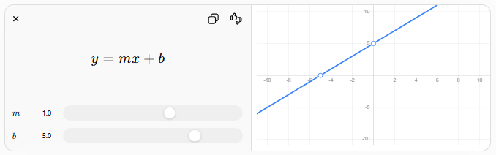
The general linear growth equation is
$$\boxed{y=mx+b}$$
where
- $y$= current value
- $x$= number of periods (or time)
- $m$= constant growth per period (growth rate in units)
- $b$= initial value

Alternative Form
# Source: AI Source: Provided by: [Data Path: Persons Table -> ID Column: 1, Name_En Column: Motasem Essam] -> From: [ChatGPT] on [7/15/2026]
If
- $V_{0}$= initial value
- $g$= constant growth per period
- $n$= number of periods
then
$$\boxed{V=V_{0}+gn}$$

Characteristics of Linear Growth
# Source: AI Source: Provided by: [Data Path: Persons Table -> ID Column: 1, Name_En Column: Motasem Essam] -> From: [ChatGPT] on [7/15/2026]
- Constant increase every period
- Straight-line graph
- Constant slope
- Constant average rate of change
- No compounding

How Linear Growth Works
# Source: AI Source: Provided by: [Data Path: Persons Table -> ID Column: 1, Name_En Column: Motasem Essam] -> From: [ChatGPT] on [7/15/2026]
Suppose
- Initial value = 100
- Growth = 15 units each year
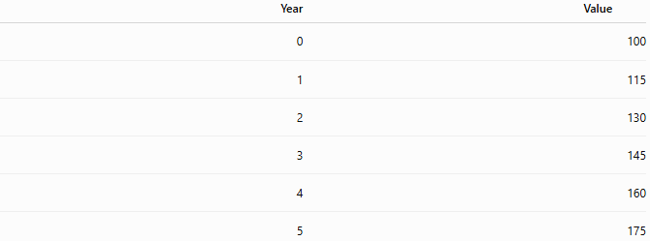
Year | Value
0 | 100
1 | 115
2 | 130
3 | 145
4 | 160
5 | 175
The increase is always
$$15$$
units.

Examples
# Source: AI Source: Provided by: [Data Path: Persons Table -> ID Column: 1, Name_En Column: Motasem Essam] -> From: [ChatGPT] on [7/15/2026]
Example 1 – Salary
Initial salary:
$$\$3000$$
Increase:
$$\$250$$
per year
After
5
years
$$3000+250(5)=4250$$

Example 2 – Savings
Initial savings:
$$\$1000$$
Deposit:
$$\$100$$
every month
After
8
months
$$1000+100(8)=1800$$

Example 3 – Tree Height
Initial height:
$$2$$
m
Growth:
$$0.4$$
m/year
After
6
years
$$2+0.4(6)=4.4$$
m

Example 4 – Factory Production
Initial production:
$$500$$
units
Increase:
$$40$$
units/week
After
10
weeks
$$500+40(10)=900$$
units

Example 5 – Population
Population:
$$20,000$$
Increase:
$$300$$
people/year
After
12
years
$$20,000+300(12)=23,600$$

Example 6 – Distance
A person walks
$$5$$
km every hour.
Starting from
0
km,
after
8
hours
$$5(8)=40$$
km

Linear Growth Table
# Source: AI Source: Provided by: [Data Path: Persons Table -> ID Column: 1, Name_En Column: Motasem Essam] -> From: [ChatGPT] on [7/15/2026]

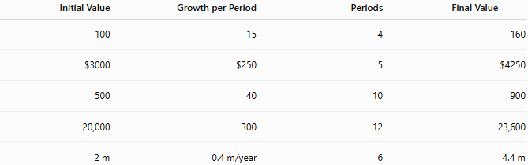
Initial Value | Growth per Period | Periods | Final Value
100 | 15 | 4 | 160
$3000 | $250 | 5 | $4250
500 | 40 | 10 | 900
20,000 | 300 | 12 | 23,600
2 m | 0.4 m/year | 6 | 4.4 m

Graph of Linear Growth
# Source: AI Source: Provided by: [Data Path: Persons Table -> ID Column: 1, Name_En Column: Motasem Essam] -> From: [ChatGPT] on [7/15/2026]
A linear growth graph is a straight line because the slope is constant.
- Equal horizontal movement produces equal vertical movement.
- The slope never changes.

Applications
# Source: AI Source: Provided by: [Data Path: Persons Table -> ID Column: 1, Name_En Column: Motasem Essam] -> From: [ChatGPT] on [7/15/2026]
Linear growth is used in:
- Arithmetic
- Algebra
- Geometry
- Engineering
- Physics
- Economics
- Business
- Statistics
- Computer Science
- Data Analysis

Real-Life Applications
# Source: AI Source: Provided by: [Data Path: Persons Table -> ID Column: 1, Name_En Column: Motasem Essam] -> From: [ChatGPT] on [7/15/2026]
Linear growth is used in:
- Fixed salary increases
- Regular monthly savings
- Constant-speed travel
- Manufacturing with fixed production increases
- Budget planning
- Inventory management
- Water tank filling at a constant rate
- Utility usage
- Construction planning
- Educational scheduling

Real-Life Examples
# Source: AI Source: Provided by: [Data Path: Persons Table -> ID Column: 1, Name_En Column: Motasem Essam] -> From: [ChatGPT] on [7/15/2026]
1. Salary
An employee receives an additional
$$\$500$$
every year.

2. Savings
A person deposits
$$\$100$$
every month.

3. Manufacturing
A factory produces
$$40$$
more products every week.

4. Distance
A car travels at a constant speed of
$$80$$
km/h.

5. Population
A village gains
$$150$$
people every year.

6. Water Tank
A tank fills at
$$25$$
liters per minute.

Common Mistakes
# Source: AI Source: Provided by: [Data Path: Persons Table -> ID Column: 1, Name_En Column: Motasem Essam] -> From: [ChatGPT] on [7/15/2026]
- Confusing linear growth with compound growth.
- Assuming a constant percentage increase is linear (it is compound/exponential growth).
- Mixing growth per period with growth percentage.
- Confusing the slope with the starting value.
- Forgetting that the increase must remain constant.

Key Points
# Source: AI Source: Provided by: [Data Path: Persons Table -> ID Column: 1, Name_En Column: Motasem Essam] -> From: [ChatGPT] on [7/15/2026]
- Linear growth adds the same amount every period.
- The graph is a straight line.
- The slope is constant.
- The average rate of change equals the growth rate.
- Linear growth does not compound.

Linear Growth vs. Simple Growth
# Source: AI Source: Provided by: [Data Path: Persons Table -> ID Column: 1, Name_En Column: Motasem Essam] -> From: [ChatGPT] on [7/15/2026]
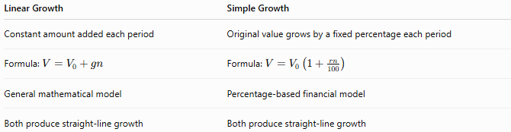
Linear Growth | Simple Growth
Constant amount added each period | Original value grows by a fixed percentage each period
Formula: $V=V_{0}+gn$ | Formula: $V=V_{0}\left(1 + \frac{rn}{100}\right)$
General mathematical model | Percentage-based financial model
Both produce straight-line growth | Both produce straight-line growth

Linear Growth vs. Compound Growth
# Source: AI Source: Provided by: [Data Path: Persons Table -> ID Column: 1, Name_En Column: Motasem Essam] -> From: [ChatGPT] on [7/15/2026]
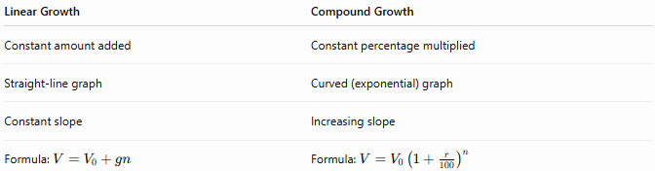
Linear Growth | Compound Growth
Constant amount added | Constant percentage multiplied
Straight-line graph | Curved (exponential) graph
Constant slope | Increasing slope
Formula: $V=V_{0}+gn$ | Formula: $V=V_{0}{\left(1 + \frac{r}{100}\right)}^{n}$

Linear Growth vs. Exponential Growth
# Source: AI Source: Provided by: [Data Path: Persons Table -> ID Column: 1, Name_En Column: Motasem Essam] -> From: [ChatGPT] on [7/15/2026]
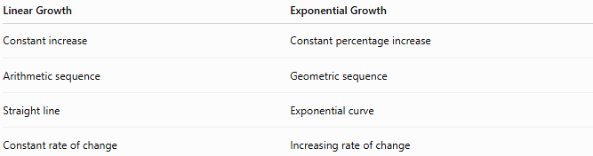
Linear Growth | Exponential Growth
Constant increase | Constant percentage increase
Arithmetic sequence | Geometric sequence
Straight line | Exponential curve
Constant rate of change | Increasing rate of change

Conclusion
# Source: AI Source: Provided by: [Data Path: Persons Table -> ID Column: 1, Name_En Column: Motasem Essam] -> From: [ChatGPT] on [7/15/2026]
Linear Growth is the process in which a quantity increases by the same fixed amount during equal time intervals. It is modeled by
$$y=mx+b$$
or
$$V=V_{0}+gn,$$
where the increase per period remains constant. Because the amount added never changes, linear growth produces a straight-line graph, a constant slope, and a constant average rate of change. Linear growth is widely used to model situations such as fixed salary increases, regular savings, constant-speed motion, production planning, and many other real-world processes where change occurs at a constant rate.

Exponential Growth
# Source: AI Source: Provided by: [Data Path: Persons Table -> ID Column: 1, Name_En Column: Motasem Essam] -> From: [ChatGPT] on [7/15/2026]
Exponential Growth is a type of growth in which a quantity increases by the same percentage (or growth factor) during equal time intervals. Unlike linear growth, the amount of increase becomes larger over time because each increase is calculated from the current value, not the original value.
Exponential growth is a fundamental concept in arithmetic, algebra, calculus, finance, economics, biology, engineering, computer science, statistics, and many scientific fields.

Definition
# Source: AI Source: Provided by: [Data Path: Persons Table -> ID Column: 1, Name_En Column: Motasem Essam] -> From: [ChatGPT] on [7/15/2026]
Exponential Growth occurs when a quantity grows by a constant percentage (or constant growth factor) over equal intervals.
If a quantity increases by
$$r\%$$
every period, then each new value is obtained by multiplying the previous value by the same growth factor.

Exponential Growth Formula
# Source: AI Source: Provided by: [Data Path: Persons Table -> ID Column: 1, Name_En Column: Motasem Essam] -> From: [ChatGPT] on [7/15/2026]
The exponential growth model is
$$\boxed{V=V_{0}{\left(1 + \frac{r}{100}\right)}^{n}}$$
where
- $V_{0}$= initial value
- $V$= value after growth
- $r$= growth rate (% per period)
- $n$= number of periods

Growth Factor
# Source: AI Source: Provided by: [Data Path: Persons Table -> ID Column: 1, Name_En Column: Motasem Essam] -> From: [ChatGPT] on [7/15/2026]
The growth factor is
$$\boxed{1+\frac{r}{100}}$$
Each period multiplies the current value by this factor.

General Exponential Function
# Source: AI Source: Provided by: [Data Path: Persons Table -> ID Column: 1, Name_En Column: Motasem Essam] -> From: [ChatGPT] on [7/15/2026]
An exponential function can also be written as
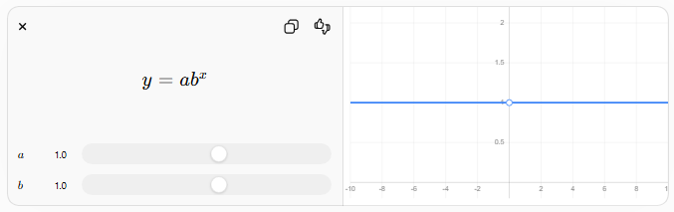
$$y=ab^{x}$$
$$a$$
$$a$$
$$b$$
$$b$$
$$\boxed{y=ab^{x}}$$
where
- $a$= initial value
- $b>1$= growth factor
- $x$= number of periods

Characteristics of Exponential Growth
# Source: AI Source: Provided by: [Data Path: Persons Table -> ID Column: 1, Name_En Column: Motasem Essam] -> From: [ChatGPT] on [7/15/2026]
- Constant percentage increase
- Increasing numerical growth
- Curved graph
- Increasing slope
- Growth accelerates over time

How Exponential Growth Works
# Source: AI Source: Provided by: [Data Path: Persons Table -> ID Column: 1, Name_En Column: Motasem Essam] -> From: [ChatGPT] on [7/15/2026]
Suppose
Initial value:
$$100$$
Growth rate:
$$20\%$$
Growth factor:
$$1.20$$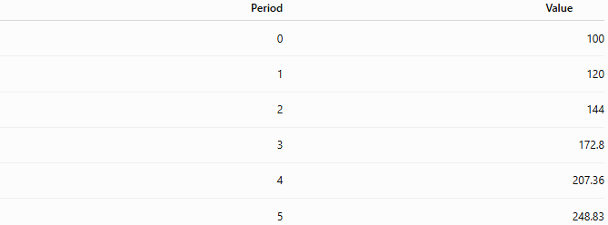
Period | Value
0 | 100
1 | 120
2 | 144
3 | 172.8
4 | 207.36
5 | 248.83
Notice that the percentage remains the same, but the amount added increases each period.

Examples
# Source: AI Source: Provided by: [Data Path: Persons Table -> ID Column: 1, Name_En Column: Motasem Essam] -> From: [ChatGPT] on [7/15/2026]
Example 1 – Investment
Investment:
$$\$1000$$
Growth:
$$5\%$$
Years:
$$6 \\ 1000(1.05)^{6}=1340.10$$

Example 2 – Population
Population:
$$20,000$$
Growth:
$$3\%$$
Years:
$$10 \\ 20,000(1.03)^{10}=26,878$$

Example 3 – Business Revenue
Revenue:
$$\$500,000$$
Growth:
$$12\%$$
Years:
$$4 \\ 500000(1.12)^{4}=786,036.16$$

Example 4 – Bacteria
Initial bacteria:
$$500$$
Growth:
$$50\%$$
Hours:
$$5 \\ 500(1.50)^{5}=3796.88$$

Example 5 – Website Visitors
Visitors:
$$10,000$$
Growth:
$$15\%$$
Months:
$$8 \\ 10,000(1.15)^{8}=30,590$$

Example 6 – Savings
Deposit:
$$\$8000$$
Interest:
$$7\%$$
Years:
$$15 \\ 8000(1.07)^{15}=22,068.24$$

Exponential Growth Table
# Source: AI Source: Provided by: [Data Path: Persons Table -> ID Column: 1, Name_En Column: Motasem Essam] -> From: [ChatGPT] on [7/15/2026]
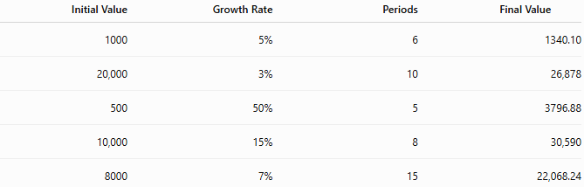
Initial Value | Growth Rate | Periods | Final Value
1000 | 5% | 6 | 1340.10
20,000 | 3% | 10 | 26,878
500 | 50% | 5 | 3796.88
10,000 | 15% | 8 | 30,590
8000 | 7% | 15 | 22,068.24

Graph of Exponential Growth
# Source: AI Source: Provided by: [Data Path: Persons Table -> ID Column: 1, Name_En Column: Motasem Essam] -> From: [ChatGPT] on [7/15/2026]
An exponential growth graph is an upward-curving graph.
Properties:
- Starts slowly.
- Becomes steeper over time.
- Never grows at a constant numerical rate.
- Growth accelerates continuously.

Applications
# Source: AI Source: Provided by: [Data Path: Persons Table -> ID Column: 1, Name_En Column: Motasem Essam] -> From: [ChatGPT] on [7/15/2026]
Exponential growth is used in:
- Arithmetic
- Algebra
- Calculus
- Finance
- Economics
- Biology
- Engineering
- Physics
- Statistics
- Computer Science

Real-Life Applications
# Source: AI Source: Provided by: [Data Path: Persons Table -> ID Column: 1, Name_En Column: Motasem Essam] -> From: [ChatGPT] on [7/15/2026]
Exponential growth is used in:
- Compound interest
- Population growth
- Investment returns
- Viral marketing
- Website traffic
- Bacterial reproduction
- Epidemic modeling
- Data storage growth
- Technology adoption
- Inflation modeling

Real-Life Examples
# Source: AI Source: Provided by: [Data Path: Persons Table -> ID Column: 1, Name_En Column: Motasem Essam] -> From: [ChatGPT] on [7/15/2026]
1. Bank Investment
Money earns
$$6\%$$
compound interest annually.

2. Population
Population grows
$$2.5\%$$
every year.

3. Business
Sales increase by
$$10\%$$
every year.

4. Bacteria
A bacterial colony doubles every few hours.

5. Internet Users
Users increase by
$$12\%$$
each month.

6. Forest Growth
Tree biomass grows by
$$4\%$$
every year.

Common Mistakes
# Source: AI Source: Provided by: [Data Path: Persons Table -> ID Column: 1, Name_En Column: Motasem Essam] -> From: [ChatGPT] on [7/15/2026]
- Confusing exponential growth with linear growth.
- Adding percentages instead of multiplying by the growth factor.
- Forgetting to convert percentages to decimals.
- Forgetting to raise the growth factor to the appropriate power.
- Assuming equal numerical increases (exponential growth has equal percentage increases).

Key Points
# Source: AI Source: Provided by: [Data Path: Persons Table -> ID Column: 1, Name_En Column: Motasem Essam] -> From: [ChatGPT] on [7/15/2026]
- Exponential growth uses a constant percentage.
- The growth factor remains constant.
- The amount of increase grows larger over time.
- The graph is curved upward.
- Exponential growth models compound processes.

Exponential Growth vs. Linear Growth
# Source: AI Source: Provided by: [Data Path: Persons Table -> ID Column: 1, Name_En Column: Motasem Essam] -> From: [ChatGPT] on [7/15/2026]
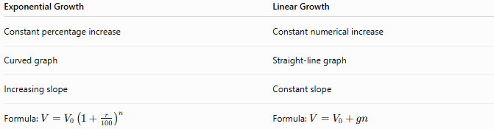
Exponential Growth | Linear Growth
Constant percentage increase | Constant numerical increase
Curved graph | Straight-line graph
Increasing slope | Constant slope
Formula: $V=V_{0}{\left(1 + \frac{r}{100}\right)}^{n}$ | Formula: $V=V_{0}+gn$

Exponential Growth vs. Compound Growth
# Source: AI Source: Provided by: [Data Path: Persons Table -> ID Column: 1, Name_En Column: Motasem Essam] -> From: [ChatGPT] on [7/15/2026]
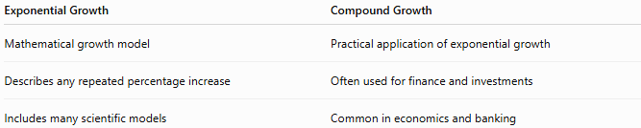
Exponential Growth | Compound Growth
Mathematical growth model | Practical application of exponential growth
Describes any repeated percentage increase | Often used for finance and investments
Includes many scientific models | Common in economics and banking

Exponential Growth vs. Geometric Sequence
# Source: AI Source: Provided by: [Data Path: Persons Table -> ID Column: 1, Name_En Column: Motasem Essam] -> From: [ChatGPT] on [7/15/2026]
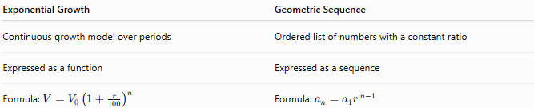
Exponential Growth | Geometric Sequence
Continuous growth model over periods | Ordered list of numbers with a constant ratio
Expressed as a function | Expressed as a sequence
Formula: $V=V_{0}{\left(1 + \frac{r}{100}\right)}^{n}$ | Formula: $a_{n}=a_{1}r^{ n-1}$

Exponential Growth vs. Exponential Decay
# Source: AI Source: Provided by: [Data Path: Persons Table -> ID Column: 1, Name_En Column: Motasem Essam] -> From: [ChatGPT] on [7/15/2026]
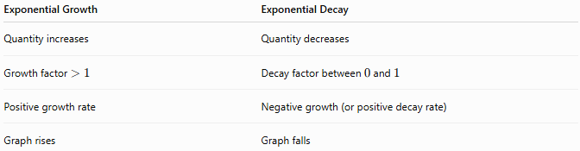
Exponential Growth | Exponential Decay
Quantity increases | Quantity decreases
Growth factor $>1$ | Decay factor between $0$and $1$
Positive growth rate | Negative growth (or positive decay rate)
Graph rises | Graph falls

Conclusion
# Source: AI Source: Provided by: [Data Path: Persons Table -> ID Column: 1, Name_En Column: Motasem Essam] -> From: [ChatGPT] on [7/15/2026]
Exponential Growth is the process in which a quantity increases by the same percentage during equal time intervals, causing the amount of increase to become larger over time. It is modeled by
$$V=V_{0}{\left(1 + \frac{r}{100}\right)}^{n},$$
where the growth factor is applied repeatedly. Because each increase is based on the current value, exponential growth produces a rapidly rising curve and accurately models many real-world phenomena such as compound interest, population growth, investments, biological reproduction, and technological expansion.

Compound Growth
# Source: AI Source: Provided by: [Data Path: Persons Table -> ID Column: 1, Name_En Column: Motasem Essam] -> From: [ChatGPT] on [7/15/2026]
Compound Growth is the process in which a quantity grows by a fixed percentage over successive periods, where each new growth is calculated from the updated value rather than the original value.
Unlike simple growth, compound growth causes the amount of increase to become larger over time because growth is earned on previous growth.
Compound growth is one of the most important concepts in arithmetic, algebra, finance, economics, engineering, population studies, biology, computer science, and statistics.

Definition
# Source: AI Source: Provided by: [Data Path: Persons Table -> ID Column: 1, Name_En Column: Motasem Essam] -> From: [ChatGPT] on [7/15/2026]
Compound Growth is repeated growth in which each growth period is based on the current value rather than the original value.
If a quantity grows by
$$r\%$$
every period, then after each period the quantity is multiplied by the growth factor
$$1+\frac{r}{100}.$$

Compound Growth Formula
# Source: AI Source: Provided by: [Data Path: Persons Table -> ID Column: 1, Name_En Column: Motasem Essam] -> From: [ChatGPT] on [7/15/2026]
The compound growth formula is
$$\boxed{V=V_{0}{\left(1 + \frac{r}{100}\right)}^{n}}$$
where
- $V_{0}$= original value
- $V$= value after growth
- $r$= growth rate (% per period)
- $n$= number of growth periods

Growth Factor
# Source: AI Source: Provided by: [Data Path: Persons Table -> ID Column: 1, Name_En Column: Motasem Essam] -> From: [ChatGPT] on [7/15/2026]
The growth factor is
$$\boxed{1+\frac{r}{100}}$$
Each period multiplies the current value by this factor.

How Compound Growth Works
# Source: AI Source: Provided by: [Data Path: Persons Table -> ID Column: 1, Name_En Column: Motasem Essam] -> From: [ChatGPT] on [7/15/2026]
Suppose
- Initial value = 100
- Growth rate = 10%
Growth factor:
$$1.10$$
Successive values:
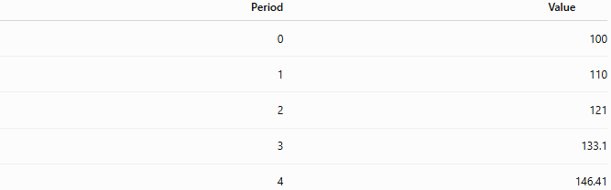
Period | Value
0 | 100
1 | 110
2 | 121
3 | 133.1
4 | 146.41
Notice that the increase becomes larger each period because each increase is calculated from the new value.

Examples
# Source: AI Source: Provided by: [Data Path: Persons Table -> ID Column: 1, Name_En Column: Motasem Essam] -> From: [ChatGPT] on [7/15/2026]
Example 1 – Savings Account
Initial balance:
$$\$1000$$
Annual growth:
$$5\%$$
Time:
$$3$$
years
$$V=1000(1.05)^{3}=1157.63$$
Answer:
$$\$1157.63$$

Example 2 – Population
Population:
$$20,000$$
Annual growth:
$$4\%$$
Years:
$$5 \\ V=20,000(1.04)^{5}=24,333$$

Example 3 – Investment
Investment:
$$\$5000$$
Growth:
$$8\%$$
Years:
$$10 \\ V=5000(1.08)^{10}=10,794.62$$

Example 4 – Company Revenue
Revenue:
$$\$250,000$$
Growth:
$$12\%$$
Years:
$$4 \\ V=250000(1.12)^{4}=393,518.08$$

Example 5 – Tree Height
Height:
$$2$$
m
Growth:
$$15\%$$
Years:
$$6 \\ V=2(1.15)^{6}=4.63\text{ m}$$

Example 6 – Website Visitors
Visitors:
$$10,000$$
Growth:
$$20\%$$
Months:
$$3 \\ V=10,000(1.20)^{3}=17,280$$

Compound Growth Table
# Source: AI Source: Provided by: [Data Path: Persons Table -> ID Column: 1, Name_En Column: Motasem Essam] -> From: [ChatGPT] on [7/15/2026]
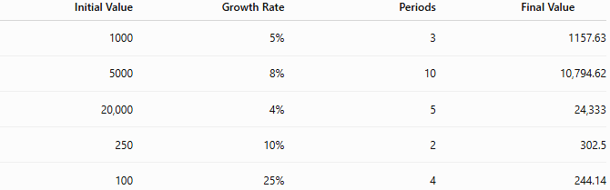
Initial Value | Growth Rate | Periods | Final Value
1000 | 5% | 3 | 1157.63
5000 | 8% | 10 | 10,794.62
20,000 | 4% | 5 | 24,333
250 | 10% | 2 | 302.5
100 | 25% | 4 | 244.14

Compound Growth vs. Simple Growth
# Source: AI Source: Provided by: [Data Path: Persons Table -> ID Column: 1, Name_En Column: Motasem Essam] -> From: [ChatGPT] on [7/15/2026]
Suppose
Initial value:
$$1000$$
Growth:
$$10\%$$
for
3
years.
Simple Growth
Each year adds
$$100 \\ 1000+300=1300$$

Compound Growth
# Source: AI Source: Provided by: [Data Path: Persons Table -> ID Column: 1, Name_En Column: Motasem Essam] -> From: [ChatGPT] on [7/15/2026]
$$1000(1.10)^{3}=1331$$
Compound growth is larger because each year's growth earns additional growth.

Applications
# Source: AI Source: Provided by: [Data Path: Persons Table -> ID Column: 1, Name_En Column: Motasem Essam] -> From: [ChatGPT] on [7/15/2026]
Compound growth is used in:
- Arithmetic
- Algebra
- Finance
- Economics
- Statistics
- Biology
- Engineering
- Computer Science
- Demography
- Data Science

Real-Life Applications
# Source: AI Source: Provided by: [Data Path: Persons Table -> ID Column: 1, Name_En Column: Motasem Essam] -> From: [ChatGPT] on [7/15/2026]
Compound growth is used in:
- Bank savings
- Investments
- Retirement funds
- Population forecasting
- Business expansion
- Inflation
- Technology adoption
- Website traffic
- Viral marketing
- Scientific modeling

Real-Life Examples
# Source: AI Source: Provided by: [Data Path: Persons Table -> ID Column: 1, Name_En Column: Motasem Essam] -> From: [ChatGPT] on [7/15/2026]
1. Savings
Deposit:
$$\$5000$$
Annual interest:
$$6\%$$
Compounded yearly.

2. Population
City population grows
$$2\%$$
every year.

3. Company Revenue
Revenue grows
$$15\%$$
each year.

4. Investments
Stock portfolio grows
$$8\%$$
annually.

5. Website Users
Users increase by
$$10\%$$
every month.

6. Forest Growth
Tree biomass increases
$$5\%$$
each year.

Common Mistakes
# Source: AI Source: Provided by: [Data Path: Persons Table -> ID Column: 1, Name_En Column: Motasem Essam] -> From: [ChatGPT] on [7/15/2026]
- Using simple growth instead of compound growth.
- Forgetting to convert percentages into decimals.
- Forgetting to raise the growth factor to the power of the number of periods.
- Using the original value instead of the current value for each period.
- Confusing compound growth with compound interest (compound interest is a specific application of compound growth).

Key Points
# Source: AI Source: Provided by: [Data Path: Persons Table -> ID Column: 1, Name_En Column: Motasem Essam] -> From: [ChatGPT] on [7/15/2026]
- Compound growth uses the current value, not the original value.
- The quantity is multiplied by the growth factor every period.
- Growth accelerates over time.
- Compound growth is modeled with exponents.
- It is the basis of many real-world growth processes.

Compound Growth vs. Simple Growth
# Source: AI Source: Provided by: [Data Path: Persons Table -> ID Column: 1, Name_En Column: Motasem Essam] -> From: [ChatGPT] on [7/15/2026]
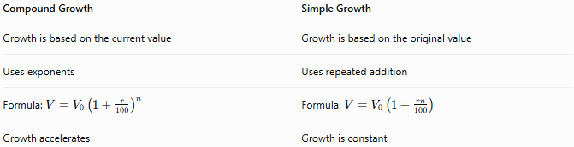
Compound Growth | Simple Growth
Growth is based on the current value | Growth is based on the original value
Uses exponents | Uses repeated addition
Formula: $V=V_{0}{\left(1 + \frac{r}{100}\right)}^{n}$ | Formula: $V=V_{0}\left(1 + \frac{rn}{100}\right)$
Growth accelerates | Growth is constant

Compound Growth vs. Exponential Growth
# Source: AI Source: Provided by: [Data Path: Persons Table -> ID Column: 1, Name_En Column: Motasem Essam] -> From: [ChatGPT] on [7/15/2026]
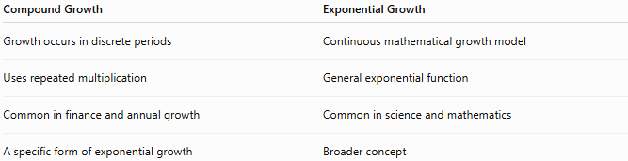
Compound Growth | Exponential Growth
Growth occurs in discrete periods | Continuous mathematical growth model
Uses repeated multiplication | General exponential function
Common in finance and annual growth | Common in science and mathematics
A specific form of exponential growth | Broader concept

Compound Growth vs. Compound Interest
# Source: AI Source: Provided by: [Data Path: Persons Table -> ID Column: 1, Name_En Column: Motasem Essam] -> From: [ChatGPT] on [7/15/2026]
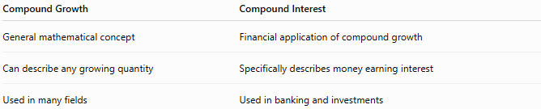
Compound Growth | Compound Interest
General mathematical concept | Financial application of compound growth
Can describe any growing quantity | Specifically describes money earning interest
Used in many fields | Used in banking and investments

Conclusion
# Source: AI Source: Provided by: [Data Path: Persons Table -> ID Column: 1, Name_En Column: Motasem Essam] -> From: [ChatGPT] on [7/15/2026]
Compound Growth is the process by which a quantity increases by a fixed percentage during each period, with every new increase calculated from the updated value rather than the original value. It is modeled by
$$V=V_{0}{\left(1 + \frac{r}{100}\right)}^{n},$$
where the growth factor is applied repeatedly over time. Because each period's growth builds upon previous growth, compound growth produces accelerating increases and is essential for understanding investments, population growth, business expansion, inflation, biological processes, and many other real-world phenomena.

Decay Rate
# Source: AI Source: Provided by: [Data Path: Persons Table -> ID Column: 1, Name_En Column: Motasem Essam] -> From: [ChatGPT] on [7/15/2026]
Decay Rate is the percentage by which a quantity decreases during each equal time interval. Unlike growth, the quantity becomes smaller over time, and each decrease is calculated from the current value, not the original value.
Decay rates are widely used in arithmetic, algebra, finance, economics, engineering, physics, biology, chemistry, computer science, and statistics.

Definition
# Source: AI Source: Provided by: [Data Path: Persons Table -> ID Column: 1, Name_En Column: Motasem Essam] -> From: [ChatGPT] on [7/15/2026]
A Decay Rate is the percentage decrease of a quantity during each period.
If a quantity decreases by
$$r\%$$
every period, then the quantity is multiplied by a decay factor during each interval.

Decay Rate Formula
# Source: AI Source: Provided by: [Data Path: Persons Table -> ID Column: 1, Name_En Column: Motasem Essam] -> From: [ChatGPT] on [7/15/2026]
If
- $V_{0}$= original value
- $V$= new value
then
$$\boxed{\text{Decay Rate}=\frac{V_{0}-V}{V_{0}}×100\%}$$

Decay Factor
# Source: AI Source: Provided by: [Data Path: Persons Table -> ID Column: 1, Name_En Column: Motasem Essam] -> From: [ChatGPT] on [7/15/2026]
The decay factor is
$$\boxed{1-\frac{r}{100}}$$
where
- $r$= decay rate (%).
The decay factor is always
$$0<\text{Decay Factor}<1.$$

Exponential Decay Formula
# Source: AI Source: Provided by: [Data Path: Persons Table -> ID Column: 1, Name_En Column: Motasem Essam] -> From: [ChatGPT] on [7/15/2026]
The value after
$$n$$
periods is
$$\boxed{V=V_{0}{\left(1 − \frac{r}{100}\right)}^{n}}$$
where
- $V_{0}$= initial value
- $V$= value after decay
- $r$= decay rate (%)
- $n$= number of periods

Characteristics of Decay
# Source: AI Source: Provided by: [Data Path: Persons Table -> ID Column: 1, Name_En Column: Motasem Essam] -> From: [ChatGPT] on [7/15/2026]
- Constant percentage decrease
- Exponential decrease
- Curved downward graph
- Decreasing slope
- Quantity approaches zero but never becomes negative through exponential decay alone

Examples
# Source: AI Source: Provided by: [Data Path: Persons Table -> ID Column: 1, Name_En Column: Motasem Essam] -> From: [ChatGPT] on [7/15/2026]
Example 1 – Car Value
Original value:
$$\$20,000$$
Annual decay:
$$10\%$$
After
3
years
Decay factor:
$$0.90 \\ 20,000(0.90)^{3}=14,580$$

Example 2 – Radioactive Material
Mass:
$$100$$
g
Decay:
$$8\%$$
After
5
years
$$100(0.92)^{5}=65.90$$
g

Example 3 – Population Decline
Population:
$$50,000$$
Decline:
$$2\%$$
After
10
years
$$50,000(0.98)^{10}=40,853$$

Example 4 – Machine Efficiency
Efficiency:
$$100\%$$
Loss:
$$5\%$$
per year
After
6
years
$$100(0.95)^{6}=73.51\%$$

Example 5 – Medicine Concentration
Initial amount:
$$250$$
mg
Decay:
$$15\%$$
per hour
After
4
hours
$$250(0.85)^{4}=130.50$$
mg

Example 6 – Computer Battery
Battery capacity:
$$100\%$$
Annual degradation:
$$4\%$$
After
5
years
$$100(0.96)^{5}=81.54\%$$

Decay Rate Table
# Source: AI Source: Provided by: [Data Path: Persons Table -> ID Column: 1, Name_En Column: Motasem Essam] -> From: [ChatGPT] on [7/15/2026]
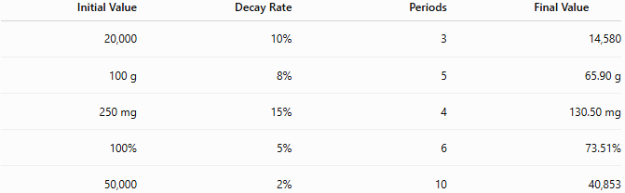
Initial Value | Decay Rate | Periods | Final Value
20,000 | 10% | 3 | 14,580
100 g | 8% | 5 | 65.90 g
250 mg | 15% | 4 | 130.50 mg
100% | 5% | 6 | 73.51%
50,000 | 2% | 10 | 40,853

Applications
# Source: AI Source: Provided by: [Data Path: Persons Table -> ID Column: 1, Name_En Column: Motasem Essam] -> From: [ChatGPT] on [7/15/2026]
Decay rates are used in:
- Arithmetic
- Algebra
- Finance
- Economics
- Engineering
- Physics
- Chemistry
- Biology
- Statistics
- Computer Science

Real-Life Applications
# Source: AI Source: Provided by: [Data Path: Persons Table -> ID Column: 1, Name_En Column: Motasem Essam] -> From: [ChatGPT] on [7/15/2026]
Decay rates are used in:
- Radioactive decay
- Vehicle depreciation
- Property depreciation
- Equipment wear
- Population decline
- Drug elimination
- Battery degradation
- Product value loss
- Inventory spoilage
- Chemical reactions

Real-Life Examples
# Source: AI Source: Provided by: [Data Path: Persons Table -> ID Column: 1, Name_En Column: Motasem Essam] -> From: [ChatGPT] on [7/15/2026]
1. Car Depreciation
A car loses
$$12\%$$
of its value each year.

2. Radioactive Material
A radioactive sample loses
$$5\%$$
of its mass each year.

3. Medicine
A drug concentration decreases by
$$20\%$$
every hour.

4. Batteries
Battery capacity decreases
$$3\%$$
every year.

5. Population
A town loses
$$1.5\%$$
of its population annually.

6. Machinery
Machine efficiency decreases
$$4\%$$
every year.

Common Mistakes
# Source: AI Source: Provided by: [Data Path: Persons Table -> ID Column: 1, Name_En Column: Motasem Essam] -> From: [ChatGPT] on [7/15/2026]
- Using the growth factor instead of the decay factor.
- Adding the decay percentage instead of subtracting it.
- Forgetting to convert percentages to decimals.
- Assuming the same numerical decrease every period (decay uses the current value, not the original value).
- Confusing decay rate with total percentage decrease over several periods.

Key Points
# Source: AI Source: Provided by: [Data Path: Persons Table -> ID Column: 1, Name_En Column: Motasem Essam] -> From: [ChatGPT] on [7/15/2026]
- Decay rate is a percentage decrease.
- The decay factor is always less than 1.
- Exponential decay uses repeated multiplication.
- The quantity decreases faster at first and more slowly later.
- Decay never becomes negative through exponential decay alone.

Decay Rate vs. Growth Rate
# Source: AI Source: Provided by: [Data Path: Persons Table -> ID Column: 1, Name_En Column: Motasem Essam] -> From: [ChatGPT] on [7/15/2026]
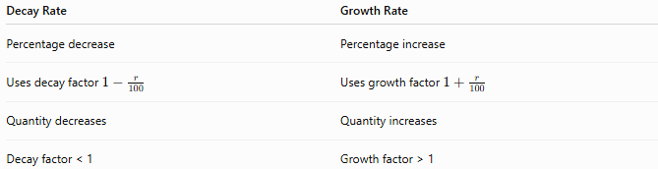
Decay Rate | Growth Rate
Percentage decrease | Percentage increase
Uses decay factor $1-\frac{r}{100}$ | Uses growth factor $1+\frac{r}{100}$
Quantity decreases | Quantity increases
Decay factor < 1 | Growth factor > 1

Decay Rate vs. Percentage Decrease
# Source: AI Source: Provided by: [Data Path: Persons Table -> ID Column: 1, Name_En Column: Motasem Essam] -> From: [ChatGPT] on [7/15/2026]
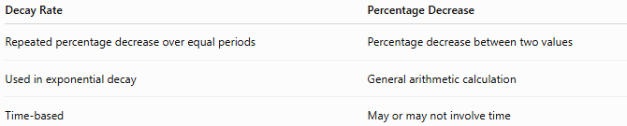
Decay Rate | Percentage Decrease
Repeated percentage decrease over equal periods | Percentage decrease between two values
Used in exponential decay | General arithmetic calculation
Time-based | May or may not involve time

Decay Rate vs. Linear Decrease
# Source: AI Source: Provided by: [Data Path: Persons Table -> ID Column: 1, Name_En Column: Motasem Essam] -> From: [ChatGPT] on [7/15/2026]
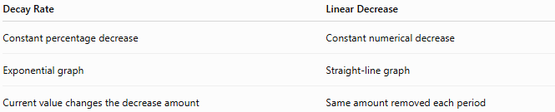
Decay Rate | Linear Decrease
Constant percentage decrease | Constant numerical decrease
Exponential graph | Straight-line graph
Current value changes the decrease amount | Same amount removed each period

Decay Rate vs. Half-Life
# Source: AI Source: Provided by: [Data Path: Persons Table -> ID Column: 1, Name_En Column: Motasem Essam] -> From: [ChatGPT] on [7/15/2026]
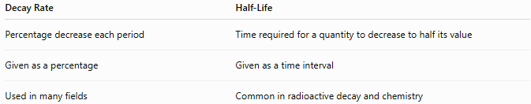
Decay Rate | Half-Life
Percentage decrease each period | Time required for a quantity to decrease to half its value
Given as a percentage | Given as a time interval
Used in many fields | Common in radioactive decay and chemistry

Conclusion
# Source: AI Source: Provided by: [Data Path: Persons Table -> ID Column: 1, Name_En Column: Motasem Essam] -> From: [ChatGPT] on [7/15/2026]
A Decay Rate measures the percentage by which a quantity decreases during each equal time interval. It is represented by the decay factor
$$1-\frac{r}{100},$$
and the value after multiple periods is calculated using
$$V=V_{0}{\left(1 − \frac{r}{100}\right)}^{n}.$$
Decay rates are fundamental in mathematics and are widely used to model depreciation, radioactive decay, population decline, battery degradation, medicine elimination, and many other real-world processes where quantities decrease exponentially over time.

Decay Factor
# Source: AI Source: Provided by: [Data Path: Persons Table -> ID Column: 1, Name_En Column: Motasem Essam] -> From: [ChatGPT] on [7/15/2026]
A Decay Factor is the multiplier used to calculate the value of a quantity after a percentage decrease during each equal time interval. Instead of repeatedly subtracting a percentage, the quantity is multiplied by the same decay factor every period.
Decay factors are widely used in arithmetic, algebra, finance, economics, engineering, biology, chemistry, physics, computer science, and statistics.

Definition
# Source: AI Source: Provided by: [Data Path: Persons Table -> ID Column: 1, Name_En Column: Motasem Essam] -> From: [ChatGPT] on [7/15/2026]
A Decay Factor is the number by which a quantity is multiplied after each period of exponential decay.
If the decay rate is
$$r\%$$
then the decay factor is
$$\boxed{1-\frac{r}{100}}$$
The decay factor is always
$$0<\text{Decay Factor}<1.$$

Decay Factor Formula
# Source: AI Source: Provided by: [Data Path: Persons Table -> ID Column: 1, Name_En Column: Motasem Essam] -> From: [ChatGPT] on [7/15/2026]
The decay factor is
$$\boxed{\text{Decay Factor}=1-\frac{r}{100}}$$
where
- $r$= decay rate (%).

Exponential Decay Formula
# Source: AI Source: Provided by: [Data Path: Persons Table -> ID Column: 1, Name_En Column: Motasem Essam] -> From: [ChatGPT] on [7/15/2026]
Using the decay factor,
$$\boxed{V=V_{0}(\text{Decay Factor})^{n}}$$
or
$$\boxed{V=V_{0}{\left(1 − \frac{r}{100}\right)}^{n}}$$
where
- $V_{0}$= initial value
- $V$= value after decay
- $n$= number of periods

Finding the Decay Rate from the Decay Factor
# Source: AI Source: Provided by: [Data Path: Persons Table -> ID Column: 1, Name_En Column: Motasem Essam] -> From: [ChatGPT] on [7/15/2026]
If the decay factor is known,
$$\boxed{\text{Decay Rate}=(1-\text{Decay Factor})×100\%}$$

Decay Factor Table
# Source: AI Source: Provided by: [Data Path: Persons Table -> ID Column: 1, Name_En Column: Motasem Essam] -> From: [ChatGPT] on [7/15/2026]
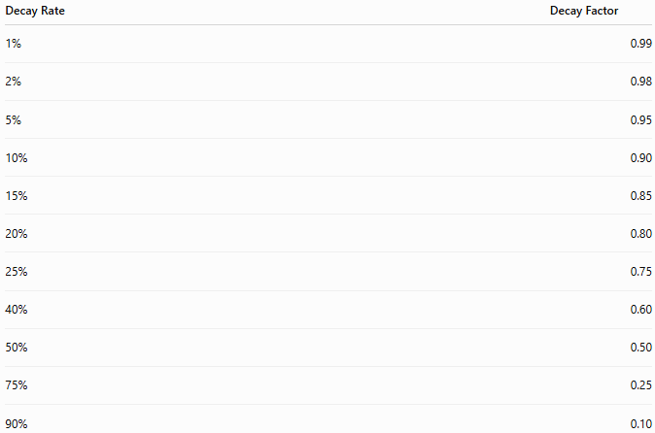
Decay Rate | Decay Factor
1% | 0.99
2% | 0.98
5% | 0.95
10% | 0.90
15% | 0.85
20% | 0.80
25% | 0.75
40% | 0.60
50% | 0.50
75% | 0.25
90% | 0.10

Examples
# Source: AI Source: Provided by: [Data Path: Persons Table -> ID Column: 1, Name_En Column: Motasem Essam] -> From: [ChatGPT] on [7/15/2026]
Example 1 – Car Depreciation
Original value:
$$\$20,000$$
Annual decay:
$$10\%$$
Decay factor:
$$0.90$$
After
3
years
$$20,000(0.90)^{3}=14,580$$

Example 2 – Battery Capacity
Initial capacity:
$$100\%$$
Annual decay:
$$4\%$$
Decay factor:
$$0.96$$
After
5
years
$$100(0.96)^{5}=81.54\%$$

Example 3 – Medicine
Initial amount:
$$500$$
mg
Decay:
$$20\%$$
per hour
Decay factor:
$$0.80$$
After
4
hours
$$500(0.80)^{4}=204.8$$
mg

Example 4 – Radioactive Material
Initial mass:
$$80$$
g
Decay:
$$6\%$$
Decay factor:
$$0.94$$
After
8
years
$$80(0.94)^{8}=48.77$$
g

Example 5 – Population Decline
Population:
$$30,000$$
Decline:
$$3\%$$
Decay factor:
$$0.97$$
After
6
years
$$30,000(0.97)^{6}=24,991$$

Example 6 – Equipment Value
Original value:
$$\$50,000$$
Annual depreciation:
$$15\%$$
Decay factor:
$$0.85$$
After
5
years
$$50,000(0.85)^{5}=22,185.31$$

Decay Factor Table with Calculations
# Source: AI Source: Provided by: [Data Path: Persons Table -> ID Column: 1, Name_En Column: Motasem Essam] -> From: [ChatGPT] on [7/15/2026]
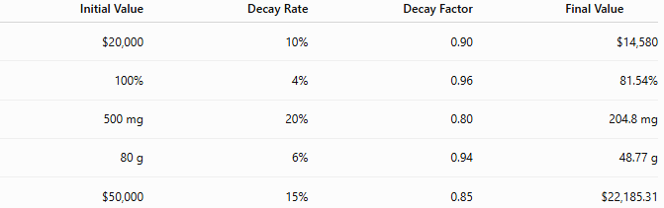
Initial Value | Decay Rate | Decay Factor | Final Value
$20,000 | 10% | 0.90 | $14,580
100% | 4% | 0.96 | 81.54%
500 mg | 20% | 0.80 | 204.8 mg
80 g | 6% | 0.94 | 48.77 g
$50,000 | 15% | 0.85 | $22,185.31

Multiple Decay Periods
# Source: AI Source: Provided by: [Data Path: Persons Table -> ID Column: 1, Name_En Column: Motasem Essam] -> From: [ChatGPT] on [7/15/2026]
For repeated decay,
$$\boxed{V=V_{0}(\text{Decay Factor})^{n}}$$
where the same decay factor is applied every period.

Applications
# Source: AI Source: Provided by: [Data Path: Persons Table -> ID Column: 1, Name_En Column: Motasem Essam] -> From: [ChatGPT] on [7/15/2026]
Decay factors are used in:
- Arithmetic
- Algebra
- Finance
- Economics
- Engineering
- Biology
- Chemistry
- Physics
- Statistics
- Computer Science

Real-Life Applications
# Source: AI Source: Provided by: [Data Path: Persons Table -> ID Column: 1, Name_En Column: Motasem Essam] -> From: [ChatGPT] on [7/15/2026]
Decay factors are used in:
- Vehicle depreciation
- Property depreciation
- Radioactive decay
- Battery degradation
- Medicine elimination
- Population decline
- Inventory spoilage
- Equipment wear
- Chemical reactions
- Product value loss

Real-Life Examples
# Source: AI Source: Provided by: [Data Path: Persons Table -> ID Column: 1, Name_En Column: Motasem Essam] -> From: [ChatGPT] on [7/15/2026]
1. Car Value
A car loses
$$12\%$$
of its value each year.
Decay factor:
$$0.88$$

2. Radioactive Material
A radioactive sample loses
$$5\%$$
each year.
Decay factor:
$$0.95$$

3. Battery Capacity
Battery capacity decreases
$$3\%$$
annually.
Decay factor:
$$0.97$$

4. Medicine
Drug concentration decreases
$$25\%$$
per hour.
Decay factor:
$$0.75$$

5. Population
A town loses
$$2\%$$
of its population each year.
Decay factor:
$$0.98$$

6. Equipment
Machine value decreases
$$10\%$$
annually.
Decay factor:
$$0.90$$

Common Mistakes
# Source: AI Source: Provided by: [Data Path: Persons Table -> ID Column: 1, Name_En Column: Motasem Essam] -> From: [ChatGPT] on [7/15/2026]
- Using the growth factor instead of the decay factor.
- Adding the percentage instead of subtracting it from 1.
- Forgetting to convert the percentage to decimal form.
- Using the original value every period instead of multiplying by the decay factor.
- Confusing the decay factor with the decay rate.

Key Points
# Source: AI Source: Provided by: [Data Path: Persons Table -> ID Column: 1, Name_En Column: Motasem Essam] -> From: [ChatGPT] on [7/15/2026]
- A decay factor is a multiplier.
- It is always greater than 0 and less than 1.
- It is used in exponential decay calculations.
- Repeated decay is modeled using powers of the decay factor.
- Smaller decay factors produce faster decreases.

Decay Factor vs. Growth Factor
# Source: AI Source: Provided by: [Data Path: Persons Table -> ID Column: 1, Name_En Column: Motasem Essam] -> From: [ChatGPT] on [7/15/2026]
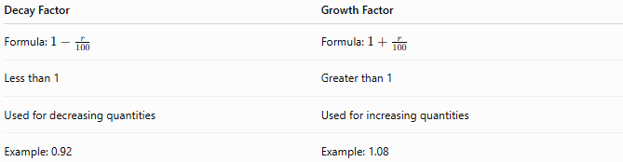
Decay Factor | Growth Factor
Formula: $1-\frac{r}{100}$ | Formula: $1+\frac{r}{100}$
Less than 1 | Greater than 1
Used for decreasing quantities | Used for increasing quantities
Example: 0.92 | Example: 1.08

Decay Factor vs. Decay Rate
# Source: AI Source: Provided by: [Data Path: Persons Table -> ID Column: 1, Name_En Column: Motasem Essam] -> From: [ChatGPT] on [7/15/2026]
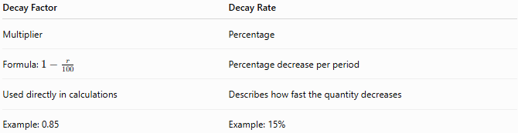
Decay Factor | Decay Rate
Multiplier | Percentage
Formula: $1-\frac{r}{100}$ | Percentage decrease per period
Used directly in calculations | Describes how fast the quantity decreases
Example: 0.85 | Example: 15%

Decay Factor vs. Half-Life
# Source: AI Source: Provided by: [Data Path: Persons Table -> ID Column: 1, Name_En Column: Motasem Essam] -> From: [ChatGPT] on [7/15/2026]
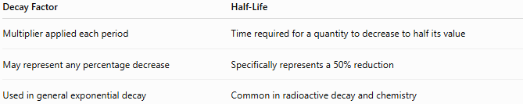
Decay Factor | Half-Life
Multiplier applied each period | Time required for a quantity to decrease to half its value
May represent any percentage decrease | Specifically represents a 50% reduction
Used in general exponential decay | Common in radioactive decay and chemistry

Conclusion
# Source: AI Source: Provided by: [Data Path: Persons Table -> ID Column: 1, Name_En Column: Motasem Essam] -> From: [ChatGPT] on [7/15/2026]
A Decay Factor is the multiplier used to calculate the remaining value of a quantity after each period of exponential decay. It is calculated by
$$1-\frac{r}{100},$$
where $r$is the decay rate expressed as a percentage. The value after multiple periods is found using
$$V=V_{0}(\text{Decay Factor})^{n},$$
making the decay factor an essential tool for modeling depreciation, radioactive decay, battery degradation, medicine elimination, population decline, and many other real-world processes involving repeated percentage decreases.

Simple Decay
# Source: AI Source: Provided by: [Data Path: Persons Table -> ID Column: 1, Name_En Column: Motasem Essam] -> From: [ChatGPT] on [7/15/2026]
Simple Decay is the process in which a quantity decreases by the same fixed amount during equal time intervals. The amount removed in each period is always calculated from the original value, not the current value.
Unlike exponential (compound) decay, simple decay does not apply the percentage decrease to the remaining value. Therefore, the amount lost each period remains constant.
Simple decay is commonly used in arithmetic, algebra, finance, engineering, economics, inventory management, depreciation models, and introductory mathematics.

Definition
# Source: AI Source: Provided by: [Data Path: Persons Table -> ID Column: 1, Name_En Column: Motasem Essam] -> From: [ChatGPT] on [7/15/2026]
Simple Decay is repeated decrease where the reduction in each period is based only on the original value.
If a quantity decreases by
$$r\%$$
per period, then each period removes the same amount:
$$\boxed{\text{Decrease per Period}=V_{0}×\frac{r}{100}}$$
where
- $V_{0}$= original value.

Simple Decay Formula
# Source: AI Source: Provided by: [Data Path: Persons Table -> ID Column: 1, Name_En Column: Motasem Essam] -> From: [ChatGPT] on [7/15/2026]
The value after
$$n$$
periods is
$$\boxed{V=V_{0}\left(1 − \frac{rn}{100}\right)}$$
where
- $V_{0}$= original value
- $V$= value after decay
- $r$= decay rate (% per period)
- $n$= number of periods

Total Decay
# Source: AI Source: Provided by: [Data Path: Persons Table -> ID Column: 1, Name_En Column: Motasem Essam] -> From: [ChatGPT] on [7/15/2026]
The total decrease is
$$\boxed{\text{Total Decay}=V_{0}×\frac{rn}{100}}$$

How Simple Decay Works
# Source: AI Source: Provided by: [Data Path: Persons Table -> ID Column: 1, Name_En Column: Motasem Essam] -> From: [ChatGPT] on [7/15/2026]
Suppose
- Initial value = 100
- Decay rate = 10%
Decrease every period:
$$100×10\%=10$$
Values become:

Period | Value
0 | 100
1 | 90
2 | 80
3 | 70
4 | 60
5 | 50
Notice that 10 is removed every period.

Examples
# Source: AI Source: Provided by: [Data Path: Persons Table -> ID Column: 1, Name_En Column: Motasem Essam] -> From: [ChatGPT] on [7/15/2026]
Example 1 – Machine Value
Original value:
$$\$10,000$$
Annual decay:
$$5\%$$
Years:
$$4$$
Decrease each year:
$$10,000×5\%=500$$
Total decrease:
$$500×4=2000$$
Final value:
$$\$8,000$$

Example 2 – Water Tank
Initial amount:
$$500$$
L
Loss:
$$8\%$$
per hour
Hours:
$$3$$
Decrease each hour:
$$500×8\%=40$$
Final amount:
$$500-120=380\text{ L}$$

Example 3 – Inventory
Initial inventory:
$$1200$$
items
Monthly loss:
$$5\%$$
Months:
$$6$$
Decrease each month:
$$60$$
items
Final inventory:
$$840$$
items

Example 4 – Fuel
Fuel:
$$80$$
L
Consumption:
$$10\%$$
per hour
Hours:
$$5$$
Decrease each hour:
$$8$$
L
Remaining fuel:
$$40$$
L

Example 5 – Battery Capacity
Battery:
$$100\%$$
Simple degradation:
$$4\%$$
per year
Years:
$$5$$
Remaining capacity:
$$100-20=80\%$$

Example 6 – Product Quantity
Products:
$$1000$$
Loss:
$$3\%$$
per week
Weeks:
$$10$$
Decrease each week:
$$30$$
Final quantity:
$$700$$

Simple Decay Table
# Source: AI Source: Provided by: [Data Path: Persons Table -> ID Column: 1, Name_En Column: Motasem Essam] -> From: [ChatGPT] on [7/15/2026]
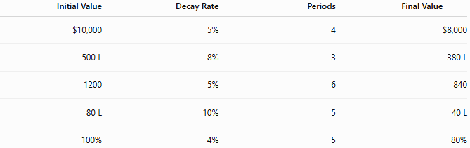
Initial Value | Decay Rate | Periods | Final Value
$10,000 | 5% | 4 | $8,000
500 L | 8% | 3 | 380 L
1200 | 5% | 6 | 840
80 L | 10% | 5 | 40 L
100% | 4% | 5 | 80%

Applications
# Source: AI Source: Provided by: [Data Path: Persons Table -> ID Column: 1, Name_En Column: Motasem Essam] -> From: [ChatGPT] on [7/15/2026]
Simple decay is used in:
- Arithmetic
- Algebra
- Engineering
- Economics
- Finance
- Inventory Management
- Manufacturing
- Education
- Budget Planning
- Linear Modeling

Real-Life Applications
# Source: AI Source: Provided by: [Data Path: Persons Table -> ID Column: 1, Name_En Column: Motasem Essam] -> From: [ChatGPT] on [7/15/2026]
Simple decay is used in:
- Fixed depreciation schedules
- Linear asset depreciation
- Inventory reduction
- Fuel consumption estimates
- Budget reductions
- Production loss planning
- Equipment wear estimates
- Educational examples
- Resource planning
- Linear forecasting

Real-Life Examples
# Source: AI Source: Provided by: [Data Path: Persons Table -> ID Column: 1, Name_En Column: Motasem Essam] -> From: [ChatGPT] on [7/15/2026]
1. Equipment
A machine loses $500 of value every year.

2. Inventory
A warehouse loses 60 products every month.

3. Fuel
A vehicle uses 8 liters of fuel every hour.

4. Battery
A battery loses 4% of its original capacity each year.

5. Water Tank
A leaking tank loses the same amount of water every hour.

6. Budget
A department's budget is reduced by the same amount each year.

Common Mistakes
# Source: AI Source: Provided by: [Data Path: Persons Table -> ID Column: 1, Name_En Column: Motasem Essam] -> From: [ChatGPT] on [7/15/2026]
- Confusing simple decay with exponential decay.
- Applying the decay percentage to the current value instead of the original value.
- Using powers in simple decay calculations.
- Assuming the amount removed changes each period.
- Allowing the formula to produce negative values without considering practical limits.

Key Points
# Source: AI Source: Provided by: [Data Path: Persons Table -> ID Column: 1, Name_En Column: Motasem Essam] -> From: [ChatGPT] on [7/15/2026]
- Simple decay is based on the original value.
- The same amount is removed every period.
- The graph is a straight line.
- No compounding occurs.
- Simple decay represents linear decrease.

Simple Decay vs. Exponential Decay
# Source: AI Source: Provided by: [Data Path: Persons Table -> ID Column: 1, Name_En Column: Motasem Essam] -> From: [ChatGPT] on [7/15/2026]
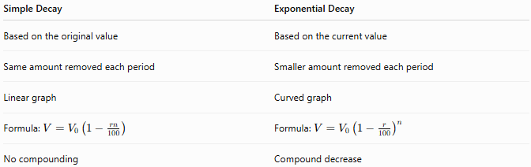
Simple Decay | Exponential Decay
Based on the original value | Based on the current value
Same amount removed each period | Smaller amount removed each period
Linear graph | Curved graph
Formula: $V=V_{0}\left(1 − \frac{rn}{100}\right)$ | Formula: $V=V_{0}{\left(1 − \frac{r}{100}\right)}^{n}$
No compounding | Compound decrease

Simple Decay vs. Linear Decrease
# Source: AI Source: Provided by: [Data Path: Persons Table -> ID Column: 1, Name_En Column: Motasem Essam] -> From: [ChatGPT] on [7/15/2026]
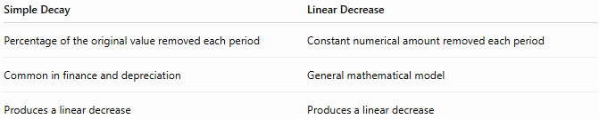
Simple Decay | Linear Decrease
Percentage of the original value removed each period | Constant numerical amount removed each period
Common in finance and depreciation | General mathematical model
Produces a linear decrease | Produces a linear decrease

Simple Decay vs. Depreciation
# Source: AI Source: Provided by: [Data Path: Persons Table -> ID Column: 1, Name_En Column: Motasem Essam] -> From: [ChatGPT] on [7/15/2026]
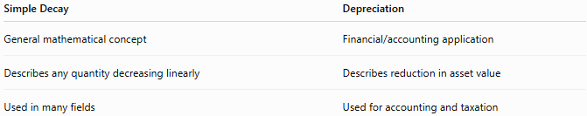
Simple Decay | Depreciation
General mathematical concept | Financial/accounting application
Describes any quantity decreasing linearly | Describes reduction in asset value
Used in many fields | Used for accounting and taxation

Conclusion
# Source: AI Source: Provided by: [Data Path: Persons Table -> ID Column: 1, Name_En Column: Motasem Essam] -> From: [ChatGPT] on [7/15/2026]
Simple Decay is the process in which a quantity decreases by the same fixed amount during equal time intervals, with each decrease calculated from the original value rather than the current value. It is modeled by
$$V=V_{0}\left(1 − \frac{rn}{100}\right),$$
which produces a linear decrease because the same amount is removed in every period. Simple decay is useful for modeling fixed depreciation, inventory reduction, fuel consumption, budget cuts, and other situations where decreases occur at a constant rate without compounding.

Linear Decay
# Source: AI Source: Provided by: [Data Path: Persons Table -> ID Column: 1, Name_En Column: Motasem Essam] -> From: [ChatGPT] on [7/15/2026]
Linear Decay is a type of decrease in which a quantity decreases by the same fixed amount during equal time intervals. The amount removed in each period is constant, so the graph of the decay is a straight line.
Unlike exponential decay, linear decay does not remove a constant percentage of the remaining value. Instead, it subtracts the same numerical amount every period.
Linear decay is widely used in arithmetic, algebra, engineering, economics, finance, physics, computer science, manufacturing, and data analysis.

Definition
# Source: AI Source: Provided by: [Data Path: Persons Table -> ID Column: 1, Name_En Column: Motasem Essam] -> From: [ChatGPT] on [7/15/2026]
Linear Decay occurs when a quantity decreases by a constant amount over equal intervals.
If the quantity decreases by
$$d$$
units every period, then the decay is linear.

Linear Decay Formula
# Source: AI Source: Provided by: [Data Path: Persons Table -> ID Column: 1, Name_En Column: Motasem Essam] -> From: [ChatGPT] on [7/15/2026]
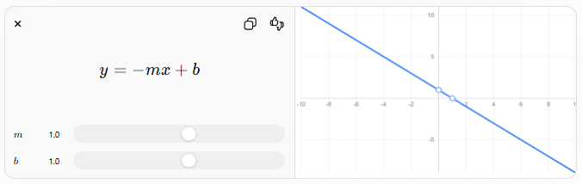
$$y=-mx+b$$
$$m$$
$$m$$
$$b$$
$$b$$
The general linear decay equation is
$$\boxed{y=-mx+b}$$
where
- $y$= current value
- $x$= number of periods (or time)
- $m$= constant amount of decrease per period
- $b$= initial value
Since $m>0$, the negative sign indicates that the quantity decreases over time.

Alternative Form
# Source: AI Source: Provided by: [Data Path: Persons Table -> ID Column: 1, Name_En Column: Motasem Essam] -> From: [ChatGPT] on [7/15/2026]
If
- $V_{0}$= initial value
- $d$= constant decrease per period
- $n$= number of periods
then
$$\boxed{V=V_{0}-dn}$$

Characteristics of Linear Decay
# Source: AI Source: Provided by: [Data Path: Persons Table -> ID Column: 1, Name_En Column: Motasem Essam] -> From: [ChatGPT] on [7/15/2026]
- Constant decrease every period
- Straight-line graph
- Constant negative slope
- Constant average rate of change
- No compounding

How Linear Decay Works
# Source: AI Source: Provided by: [Data Path: Persons Table -> ID Column: 1, Name_En Column: Motasem Essam] -> From: [ChatGPT] on [7/15/2026]
Suppose
- Initial value = 100
- Decrease = 15 units each year
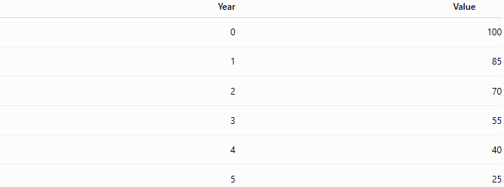
Year | Value
0 | 100
1 | 85
2 | 70
3 | 55
4 | 40
5 | 25
The decrease is always
$$15$$
units.

Examples
# Source: AI Source: Provided by: [Data Path: Persons Table -> ID Column: 1, Name_En Column: Motasem Essam] -> From: [ChatGPT] on [7/15/2026]
Example 1 – Fuel
Fuel:
$$100$$
L
Consumption:
$$8$$
L/hour
After
6
hours
$$100-8(6)=52$$
L

Example 2 – Inventory
Inventory:
$$500$$
items
Loss:
$$20$$
items/day
After
15
days
$$500-20(15)=200$$
items

Example 3 – Battery
Battery:
$$100\%$$
Capacity decreases
$$4$$
percentage points each year
After
10
years
$$100-4(10)=60\%$$

Example 4 – Machine Value
Machine value:
$$\$50,000$$
Depreciation:
$$\$3000$$
per year
After
8
years
$$50,000-3000(8)=26,000$$

Example 5 – Water Tank
Water:
$$800$$
L
Leak:
$$25$$
L/hour
After
20
hours
$$800-25(20)=300$$
L

Example 6 – Population
Population:
$$10,000$$
Loss:
$$150$$
people/year
After
12
years
$$10,000-150(12)=8,200$$
people

Linear Decay Table
# Source: AI Source: Provided by: [Data Path: Persons Table -> ID Column: 1, Name_En Column: Motasem Essam] -> From: [ChatGPT] on [7/15/2026]
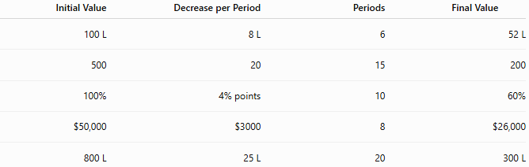
Initial Value | Decrease per Period | Periods | Final Value
100 L | 8 L | 6 | 52 L
500 | 20 | 15 | 200
100% | 4% points | 10 | 60%
$50,000 | $3000 | 8 | $26,000
800 L | 25 L | 20 | 300 L

Graph of Linear Decay
# Source: AI Source: Provided by: [Data Path: Persons Table -> ID Column: 1, Name_En Column: Motasem Essam] -> From: [ChatGPT] on [7/15/2026]
A linear decay graph is a straight line sloping downward.
Properties:
- Equal horizontal movement produces equal downward movement.
- The slope is constant and negative.
- The quantity decreases uniformly.

Applications
# Source: AI Source: Provided by: [Data Path: Persons Table -> ID Column: 1, Name_En Column: Motasem Essam] -> From: [ChatGPT] on [7/15/2026]
Linear decay is used in:
- Arithmetic
- Algebra
- Engineering
- Economics
- Finance
- Physics
- Manufacturing
- Statistics
- Computer Science
- Data Analysis

Real-Life Applications
# Source: AI Source: Provided by: [Data Path: Persons Table -> ID Column: 1, Name_En Column: Motasem Essam] -> From: [ChatGPT] on [7/15/2026]
Linear decay is used in:
- Fixed annual depreciation
- Fuel consumption
- Water leakage
- Inventory reduction
- Resource depletion
- Budget reductions
- Manufacturing losses
- Warehouse management
- Equipment wear estimates
- Project scheduling

Real-Life Examples
# Source: AI Source: Provided by: [Data Path: Persons Table -> ID Column: 1, Name_En Column: Motasem Essam] -> From: [ChatGPT] on [7/15/2026]
1. Fuel Tank
A vehicle uses
$$8$$
liters of fuel every hour.

2. Inventory
A warehouse removes
$$20$$
products every day.

3. Machine Value
Equipment loses
$$\$3000$$
of value each year.

4. Water Tank
A leaking tank loses
$$25$$
liters every hour.

5. Population
A town loses
$$150$$
people every year.

6. Battery
Battery capacity decreases by
$$4$$
percentage points every year.

Common Mistakes
# Source: AI Source: Provided by: [Data Path: Persons Table -> ID Column: 1, Name_En Column: Motasem Essam] -> From: [ChatGPT] on [7/15/2026]
- Confusing linear decay with exponential decay.
- Assuming a constant percentage decrease is linear.
- Using multiplication instead of repeated subtraction.
- Forgetting that the decrease must remain constant.
- Confusing the negative slope with the initial value.

Key Points
# Source: AI Source: Provided by: [Data Path: Persons Table -> ID Column: 1, Name_En Column: Motasem Essam] -> From: [ChatGPT] on [7/15/2026]
- Linear decay removes the same amount every period.
- The graph is a straight line with a negative slope.
- The average rate of change is constant.
- No compounding occurs.
- Linear decay eventually reaches zero unless the model is limited beforehand.

Linear Decay vs. Exponential Decay
# Source: AI Source: Provided by: [Data Path: Persons Table -> ID Column: 1, Name_En Column: Motasem Essam] -> From: [ChatGPT] on [7/15/2026]
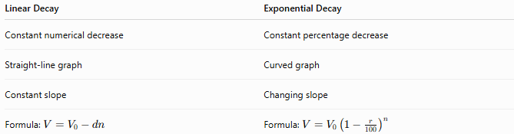
Linear Decay | Exponential Decay
Constant numerical decrease | Constant percentage decrease
Straight-line graph | Curved graph
Constant slope | Changing slope
Formula: $V=V_{0}-dn$ | Formula: $V=V_{0}{\left(1 − \frac{r}{100}\right)}^{n}$

Linear Decay vs. Simple Decay
# Source: AI Source: Provided by: [Data Path: Persons Table -> ID Column: 1, Name_En Column: Motasem Essam] -> From: [ChatGPT] on [7/15/2026]
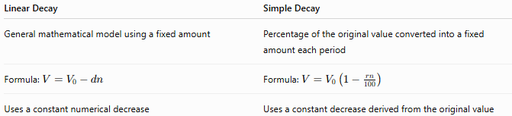
Linear Decay | Simple Decay
General mathematical model using a fixed amount | Percentage of the original value converted into a fixed amount each period
Formula: $V=V_{0}-dn$ | Formula: $V=V_{0}\left(1 − \frac{rn}{100}\right)$
Uses a constant numerical decrease | Uses a constant decrease derived from the original value

Linear Decay vs. Linear Growth
# Source: AI Source: Provided by: [Data Path: Persons Table -> ID Column: 1, Name_En Column: Motasem Essam] -> From: [ChatGPT] on [7/15/2026]
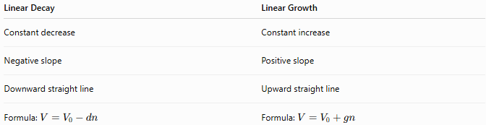
Linear Decay | Linear Growth
Constant decrease | Constant increase
Negative slope | Positive slope
Downward straight line | Upward straight line
Formula: $V=V_{0}-dn$ | Formula: $V=V_{0}+gn$

Conclusion
# Source: AI Source: Provided by: [Data Path: Persons Table -> ID Column: 1, Name_En Column: Motasem Essam] -> From: [ChatGPT] on [7/15/2026]
Linear Decay is the process in which a quantity decreases by the same fixed amount during equal time intervals. It is modeled by
$$V=V_{0}-dn$$
or equivalently by the linear equation
$$y=-mx+b,$$
where the slope is negative because the quantity is decreasing. Linear decay produces a straight-line graph, a constant negative rate of change, and is commonly used to model fixed depreciation, fuel consumption, inventory reduction, water leakage, and many other situations where a quantity decreases uniformly over time.

Exponential Decay
# Source: AI Source: Provided by: [Data Path: Persons Table -> ID Column: 1, Name_En Column: Motasem Essam] -> From: [ChatGPT] on [7/15/2026]
Exponential Decay is a type of decrease in which a quantity decreases by the same percentage during equal time intervals. Unlike linear decay, the amount removed becomes smaller over time because the percentage is always applied to the current value, not the original value.
Exponential decay is one of the most important concepts in arithmetic, algebra, calculus, finance, economics, engineering, biology, chemistry, physics, computer science, and statistics.

Definition
# Source: AI Source: Provided by: [Data Path: Persons Table -> ID Column: 1, Name_En Column: Motasem Essam] -> From: [ChatGPT] on [7/15/2026]
Exponential Decay occurs when a quantity decreases by a constant percentage (or constant decay factor) over equal intervals.
If a quantity decreases by
$$r\%$$
every period, then each new value is obtained by multiplying the previous value by the same decay factor.

Exponential Decay Formula
# Source: AI Source: Provided by: [Data Path: Persons Table -> ID Column: 1, Name_En Column: Motasem Essam] -> From: [ChatGPT] on [7/15/2026]
The exponential decay model is
$$\boxed{V=V_{0}{\left(1 − \frac{r}{100}\right)}^{n}}$$
where
- $V_{0}$= initial value
- $V$= value after decay
- $r$= decay rate (% per period)
- $n$= number of periods

Decay Factor
# Source: AI Source: Provided by: [Data Path: Persons Table -> ID Column: 1, Name_En Column: Motasem Essam] -> From: [ChatGPT] on [7/15/2026]
The decay factor is
$$\boxed{1-\frac{r}{100}}$$
where
$$0<1-\frac{r}{100}<1.$$
Each period multiplies the current value by this factor.

General Exponential Function
# Source: AI Source: Provided by: [Data Path: Persons Table -> ID Column: 1, Name_En Column: Motasem Essam] -> From: [ChatGPT] on [7/15/2026]
An exponential decay function can also be written as
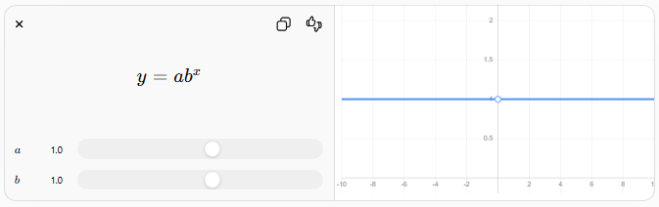
$$y=ab^{x}$$
$$a$$
$$a$$
$$b$$
$$b$$
with
- $a>0$
- $0<b<1$
so that
$$\boxed{y=ab^{x}}$$
where
- $a$= initial value
- $b$= decay factor
- $x$= number of periods

Characteristics of Exponential Decay
# Source: AI Source: Provided by: [Data Path: Persons Table -> ID Column: 1, Name_En Column: Motasem Essam] -> From: [ChatGPT] on [7/15/2026]
- Constant percentage decrease
- Decreasing numerical loss over time
- Curved downward graph
- Decreasing slope magnitude
- Quantity approaches zero but never reaches zero through exponential decay alone

How Exponential Decay Works
# Source: AI Source: Provided by: [Data Path: Persons Table -> ID Column: 1, Name_En Column: Motasem Essam] -> From: [ChatGPT] on [7/15/2026]
Suppose
Initial value:
$$100$$
Decay rate:
$$20\%$$
Decay factor:
$$0.80$$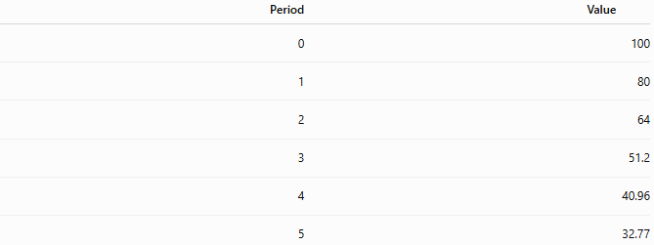
Period | Value
0 | 100
1 | 80
2 | 64
3 | 51.2
4 | 40.96
5 | 32.77
Notice that the percentage remains constant, but the amount removed becomes smaller because it is always calculated from the remaining value.

Examples
# Source: AI Source: Provided by: [Data Path: Persons Table -> ID Column: 1, Name_En Column: Motasem Essam] -> From: [ChatGPT] on [7/15/2026]
Example 1 – Car Depreciation
Original value:
$$\$30,000$$
Annual depreciation:
$$10\%$$
Years:
$$5 \\ 30,000(0.90)^{5}=17,714.70$$

Example 2 – Radioactive Material
Initial mass:
$$200$$
g
Decay:
$$5\%$$
Years:
$$10 \\ 200(0.95)^{10}=119.75$$
g

Example 3 – Medicine
Initial dose:
$$500$$
mg
Decay:
$$25\%$$
per hour
Hours:
$$4 \\ 500(0.75)^{4}=158.20$$
mg

Example 4 – Battery Capacity
Initial capacity:
$$100\%$$
Annual degradation:
$$3\%$$
Years:
$$8 \\ 100(0.97)^{8}=78.37\%$$

Example 5 – Population Decline
Population:
$$80,000$$
Decline:
$$2\%$$
Years:
$$12 \\ 80,000(0.98)^{12}=62,770$$

Example 6 – Product Value
Value:
$$\$12,000$$
Depreciation:
$$15\%$$
Years:
$$6 \\ 12,000(0.85)^{6}=4,531.92$$

Exponential Decay Table
# Source: AI Source: Provided by: [Data Path: Persons Table -> ID Column: 1, Name_En Column: Motasem Essam] -> From: [ChatGPT] on [7/15/2026]
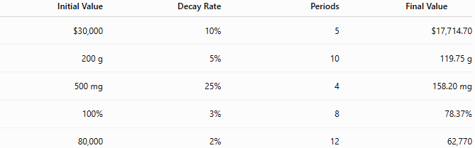
Initial Value | Decay Rate | Periods | Final Value
$30,000 | 10% | 5 | $17,714.70
200 g | 5% | 10 | 119.75 g
500 mg | 25% | 4 | 158.20 mg
100% | 3% | 8 | 78.37%
80,000 | 2% | 12 | 62,770

Graph of Exponential Decay
# Source: AI Source: Provided by: [Data Path: Persons Table -> ID Column: 1, Name_En Column: Motasem Essam] -> From: [ChatGPT] on [7/15/2026]
An exponential decay graph is a downward-curving graph.
Properties:
- Falls rapidly at first.
- Becomes flatter over time.
- Approaches zero asymptotically.
- Never reaches zero in the mathematical model.

Applications
# Source: AI Source: Provided by: [Data Path: Persons Table -> ID Column: 1, Name_En Column: Motasem Essam] -> From: [ChatGPT] on [7/15/2026]
Exponential decay is used in:
- Arithmetic
- Algebra
- Calculus
- Finance
- Economics
- Biology
- Chemistry
- Physics
- Statistics
- Computer Science

Real-Life Applications
# Source: AI Source: Provided by: [Data Path: Persons Table -> ID Column: 1, Name_En Column: Motasem Essam] -> From: [ChatGPT] on [7/15/2026]
Exponential decay is used in:
- Radioactive decay
- Carbon dating
- Drug elimination
- Battery degradation
- Vehicle depreciation
- Equipment depreciation
- Population decline
- Chemical reactions
- Heat cooling models
- Financial depreciation

Real-Life Examples
# Source: AI Source: Provided by: [Data Path: Persons Table -> ID Column: 1, Name_En Column: Motasem Essam] -> From: [ChatGPT] on [7/15/2026]
1. Radioactive Decay
A radioactive isotope loses
$$5\%$$
of its mass every year.

2. Medicine
A drug concentration decreases by
$$20\%$$
every hour.

3. Battery
Battery capacity decreases by
$$3\%$$
each year.

4. Vehicle
A vehicle loses
$$12\%$$
of its value annually.

5. Population
A town loses
$$2\%$$
of its population every year.

6. Electronics
Electronic components lose efficiency by a fixed percentage each year.

Common Mistakes
# Source: AI Source: Provided by: [Data Path: Persons Table -> ID Column: 1, Name_En Column: Motasem Essam] -> From: [ChatGPT] on [7/15/2026]
- Confusing exponential decay with linear decay.
- Subtracting a fixed amount instead of multiplying by the decay factor.
- Forgetting to convert percentages to decimals.
- Forgetting to raise the decay factor to the appropriate power.
- Assuming the numerical amount removed remains constant.

Key Points
# Source: AI Source: Provided by: [Data Path: Persons Table -> ID Column: 1, Name_En Column: Motasem Essam] -> From: [ChatGPT] on [7/15/2026]
- Exponential decay uses a constant percentage decrease.
- The decay factor remains constant.
- The amount removed decreases over time.
- The graph is curved downward.
- Exponential decay models many natural and financial processes.

Exponential Decay vs. Linear Decay
# Source: AI Source: Provided by: [Data Path: Persons Table -> ID Column: 1, Name_En Column: Motasem Essam] -> From: [ChatGPT] on [7/15/2026]
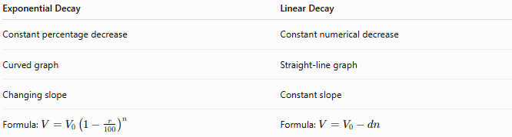
Exponential Decay | Linear Decay
Constant percentage decrease | Constant numerical decrease
Curved graph | Straight-line graph
Changing slope | Constant slope
Formula: $V=V_{0}{\left(1 − \frac{r}{100}\right)}^{n}$ | Formula: $V=V_{0}-dn$

Exponential Decay vs. Compound Decay
# Source: AI Source: Provided by: [Data Path: Persons Table -> ID Column: 1, Name_En Column: Motasem Essam] -> From: [ChatGPT] on [7/15/2026]
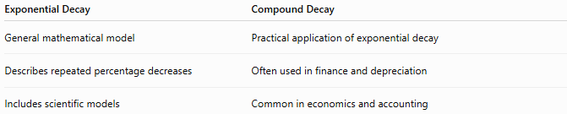
Exponential Decay | Compound Decay
General mathematical model | Practical application of exponential decay
Describes repeated percentage decreases | Often used in finance and depreciation
Includes scientific models | Common in economics and accounting

Exponential Decay vs. Half-Life
# Source: AI Source: Provided by: [Data Path: Persons Table -> ID Column: 1, Name_En Column: Motasem Essam] -> From: [ChatGPT] on [7/15/2026]
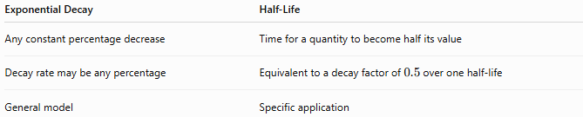
Exponential Decay | Half-Life
Any constant percentage decrease | Time for a quantity to become half its value
Decay rate may be any percentage | Equivalent to a decay factor of $0.5$over one half-life
General model | Specific application

Exponential Decay vs. Exponential Growth
# Source: AI Source: Provided by: [Data Path: Persons Table -> ID Column: 1, Name_En Column: Motasem Essam] -> From: [ChatGPT] on [7/15/2026]
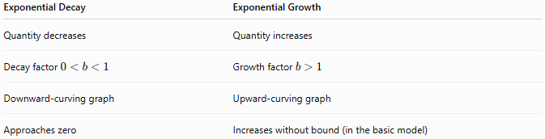
Exponential Decay | Exponential Growth
Quantity decreases | Quantity increases
Decay factor $0<b<1$ | Growth factor $b>1$
Downward-curving graph | Upward-curving graph
Approaches zero | Increases without bound (in the basic model)

Conclusion
# Source: AI Source: Provided by: [Data Path: Persons Table -> ID Column: 1, Name_En Column: Motasem Essam] -> From: [ChatGPT] on [7/15/2026]
Exponential Decay is the process in which a quantity decreases by the same percentage during equal time intervals, causing the numerical amount of decrease to become smaller over time. It is modeled by
$$V=V_{0}{\left(1 − \frac{r}{100}\right)}^{n},$$
where the decay factor is applied repeatedly to the current value. Because each decrease is based on the remaining quantity, exponential decay produces a downward-curving graph and accurately models many real-world phenomena such as radioactive decay, depreciation, drug elimination, battery degradation, and population decline.

Compound Decay
# Source: AI Source: Provided by: [Data Path: Persons Table -> ID Column: 1, Name_En Column: Motasem Essam] -> From: [ChatGPT] on [7/15/2026]
Compound Decay is the process in which a quantity decreases by a fixed percentage during successive equal time intervals, where each new decrease is calculated from the current value rather than the original value.
Unlike simple decay, compound decay causes the amount of decrease to become smaller over time, because each percentage reduction is applied to the remaining quantity.
Compound decay is widely used in arithmetic, algebra, finance, economics, engineering, biology, chemistry, physics, computer science, and statistics.

Definition
# Source: AI Source: Provided by: [Data Path: Persons Table -> ID Column: 1, Name_En Column: Motasem Essam] -> From: [ChatGPT] on [7/15/2026]
Compound Decay is repeated percentage-based decrease in which every period's decrease is calculated from the current value.
If a quantity decreases by
$$r\%$$
each period, then each new value is obtained by multiplying the previous value by the decay factor.

Compound Decay Formula
# Source: AI Source: Provided by: [Data Path: Persons Table -> ID Column: 1, Name_En Column: Motasem Essam] -> From: [ChatGPT] on [7/15/2026]
The compound decay formula is
$$\boxed{V=V_{0}{\left(1 − \frac{r}{100}\right)}^{n}}$$
where
- $V_{0}$= original value
- $V$= value after decay
- $r$= decay rate (% per period)
- $n$= number of periods

Decay Factor
# Source: AI Source: Provided by: [Data Path: Persons Table -> ID Column: 1, Name_En Column: Motasem Essam] -> From: [ChatGPT] on [7/15/2026]
The decay factor is
$$\boxed{1-\frac{r}{100}}$$
where
$$0<1-\frac{r}{100}<1.$$
Each period multiplies the remaining value by this factor.

How Compound Decay Works
# Source: AI Source: Provided by: [Data Path: Persons Table -> ID Column: 1, Name_En Column: Motasem Essam] -> From: [ChatGPT] on [7/15/2026]
Suppose
- Initial value = 100
- Decay rate = 20%
Decay factor:
$$0.80$$
Successive values:
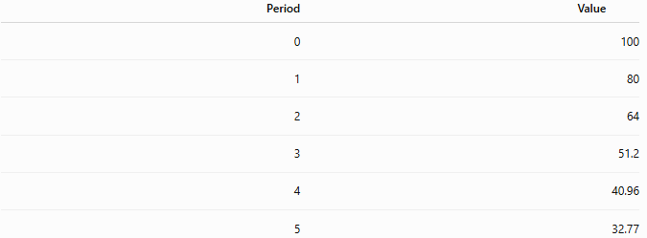
Period | Value
0 | 100
1 | 80
2 | 64
3 | 51.2
4 | 40.96
5 | 32.77
Notice that the percentage stays the same, but the amount removed becomes smaller because it is always calculated from the remaining value.

Examples
# Source: AI Source: Provided by: [Data Path: Persons Table -> ID Column: 1, Name_En Column: Motasem Essam] -> From: [ChatGPT] on [7/15/2026]
Example 1 – Car Depreciation
Original value:
$$\$25,000$$
Annual depreciation:
$$10\%$$
Years:
$$4 \\ 25,000(0.90)^{4}=16,402.50$$

Example 2 – Medicine
Initial dose:
$$400$$
mg
Decay:
$$20\%$$
per hour
Hours:
$$5 \\ 400(0.80)^{5}=131.07$$
mg

Example 3 – Radioactive Material
Initial mass:
$$150$$
g
Decay:
$$6\%$$
Years:
$$8 \\ 150(0.94)^{8}=91.45$$
g

Example 4 – Battery Capacity
Initial capacity:
$$100\%$$
Annual degradation:
$$4\%$$
Years:
$$10 \\ 100(0.96)^{10}=66.48\%$$

Example 5 – Population Decline
Population:
$$60,000$$
Decline:
$$3\%$$
Years:
$$7 \\ 60,000(0.97)^{7}=48,459$$

Example 6 – Product Value
Original value:
$$\$8,000$$
Annual depreciation:
$$15\%$$
Years:
$$6 \\ 8,000(0.85)^{6}=3,021.28$$

Compound Decay Table
# Source: AI Source: Provided by: [Data Path: Persons Table -> ID Column: 1, Name_En Column: Motasem Essam] -> From: [ChatGPT] on [7/15/2026]
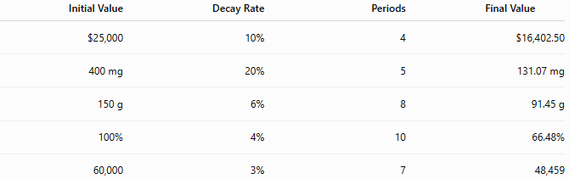
Initial Value | Decay Rate | Periods | Final Value
$25,000 | 10% | 4 | $16,402.50
400 mg | 20% | 5 | 131.07 mg
150 g | 6% | 8 | 91.45 g
100% | 4% | 10 | 66.48%
60,000 | 3% | 7 | 48,459

Applications
# Source: AI Source: Provided by: [Data Path: Persons Table -> ID Column: 1, Name_En Column: Motasem Essam] -> From: [ChatGPT] on [7/15/2026]
Compound decay is used in:
- Arithmetic
- Algebra
- Finance
- Economics
- Engineering
- Biology
- Chemistry
- Physics
- Statistics
- Computer Science

Real-Life Applications
# Source: AI Source: Provided by: [Data Path: Persons Table -> ID Column: 1, Name_En Column: Motasem Essam] -> From: [ChatGPT] on [7/15/2026]
Compound decay is used in:
- Vehicle depreciation
- Equipment depreciation
- Battery degradation
- Drug elimination
- Radioactive decay
- Population decline
- Product value reduction
- Chemical decomposition
- Financial asset depreciation
- Electronic component aging

Real-Life Examples
# Source: AI Source: Provided by: [Data Path: Persons Table -> ID Column: 1, Name_En Column: Motasem Essam] -> From: [ChatGPT] on [7/15/2026]
1. Vehicle
A car loses
$$12\%$$
of its remaining value each year.

2. Radioactive Material
A radioactive substance loses
$$5\%$$
of its remaining mass annually.

3. Medicine
A drug concentration decreases by
$$25\%$$
every hour.

4. Battery
Battery capacity decreases by
$$3\%$$
of its remaining capacity each year.

5. Population
A city's population decreases by
$$2\%$$
each year.

6. Electronics
Electronic components lose
$$8\%$$
of their remaining efficiency annually.

Common Mistakes
# Source: AI Source: Provided by: [Data Path: Persons Table -> ID Column: 1, Name_En Column: Motasem Essam] -> From: [ChatGPT] on [7/15/2026]
- Confusing compound decay with simple decay.
- Subtracting the percentage directly instead of multiplying by the decay factor.
- Forgetting to convert percentages to decimals.
- Forgetting to raise the decay factor to the correct power.
- Assuming the same numerical amount is removed every period.

Key Points
# Source: AI Source: Provided by: [Data Path: Persons Table -> ID Column: 1, Name_En Column: Motasem Essam] -> From: [ChatGPT] on [7/15/2026]
- Compound decay uses a constant percentage decrease.
- The decay factor remains constant.
- The amount removed becomes smaller over time.
- Compound decay is mathematically equivalent to exponential decay.
- The graph is a downward-curving exponential graph.

Compound Decay vs. Simple Decay
# Source: AI Source: Provided by: [Data Path: Persons Table -> ID Column: 1, Name_En Column: Motasem Essam] -> From: [ChatGPT] on [7/15/2026]
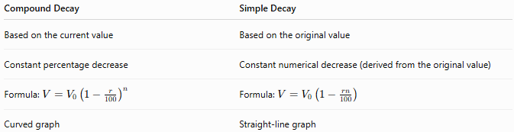
Compound Decay | Simple Decay
Based on the current value | Based on the original value
Constant percentage decrease | Constant numerical decrease (derived from the original value)
Formula: $V=V_{0}{\left(1 − \frac{r}{100}\right)}^{n}$ | Formula: $V=V_{0}\left(1 − \frac{rn}{100}\right)$
Curved graph | Straight-line graph

Compound Decay vs. Exponential Decay
# Source: AI Source: Provided by: [Data Path: Persons Table -> ID Column: 1, Name_En Column: Motasem Essam] -> From: [ChatGPT] on [7/15/2026]
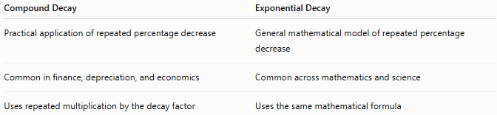
Compound Decay | Exponential Decay
Practical application of repeated percentage decrease | General mathematical model of repeated percentage decrease
Common in finance, depreciation, and economics | Common across mathematics and science
Uses repeated multiplication by the decay factor | Uses the same mathematical formula

Compound Decay vs. Compound Growth
# Source: AI Source: Provided by: [Data Path: Persons Table -> ID Column: 1, Name_En Column: Motasem Essam] -> From: [ChatGPT] on [7/15/2026]
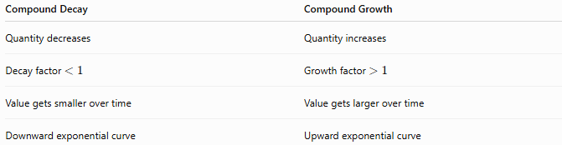
Compound Decay | Compound Growth
Quantity decreases | Quantity increases
Decay factor $<1$ | Growth factor $>1$
Value gets smaller over time | Value gets larger over time
Downward exponential curve | Upward exponential curve

Compound Decay vs. Half-Life
# Source: AI Source: Provided by: [Data Path: Persons Table -> ID Column: 1, Name_En Column: Motasem Essam] -> From: [ChatGPT] on [7/15/2026]
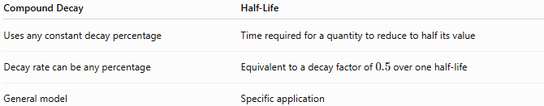
Compound Decay | Half-Life
Uses any constant decay percentage | Time required for a quantity to reduce to half its value
Decay rate can be any percentage | Equivalent to a decay factor of $0.5$over one half-life
General model | Specific application

Conclusion
# Source: AI Source: Provided by: [Data Path: Persons Table -> ID Column: 1, Name_En Column: Motasem Essam] -> From: [ChatGPT] on [7/15/2026]
Compound Decay is the process in which a quantity decreases by the same percentage during successive equal time intervals, with each decrease calculated from the current value rather than the original value. It is modeled by
$$V=V_{0}{\left(1 − \frac{r}{100}\right)}^{n},$$
where the decay factor is repeatedly applied to the remaining quantity. Compound decay is mathematically equivalent to exponential decay and is widely used to model depreciation, radioactive decay, medicine elimination, battery degradation, population decline, and many other real-world processes involving repeated percentage decreases.

Half-Life
# Source: AI Source: Provided by: [Data Path: Persons Table -> ID Column: 1, Name_En Column: Motasem Essam] -> From: [ChatGPT] on [7/15/2026]
Half-Life is the time required for a quantity to decrease to one-half of its original amount through exponential decay. After each half-life, the remaining quantity is always 50% of the amount at the beginning of that interval, regardless of the starting value.
Half-life is a fundamental concept in mathematics, chemistry, physics, biology, engineering, medicine, environmental science, and nuclear science.

Definition
# Source: AI Source: Provided by: [Data Path: Persons Table -> ID Column: 1, Name_En Column: Motasem Essam] -> From: [ChatGPT] on [7/15/2026]
A Half-Life is the fixed amount of time required for a quantity undergoing exponential decay to be reduced to one-half of its current value.
Unlike linear decay, half-life always represents repeated halving, making it an example of exponential decay.

Half-Life Formula
# Source: AI Source: Provided by: [Data Path: Persons Table -> ID Column: 1, Name_En Column: Motasem Essam] -> From: [ChatGPT] on [7/15/2026]
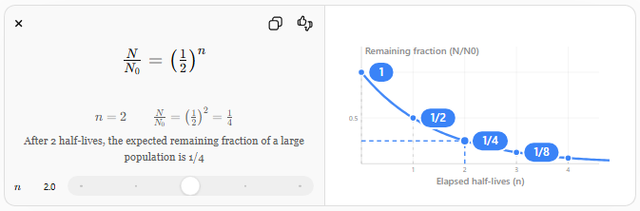
The quantity remaining after
$$n$$
half-lives is
$$\boxed{\frac{N}{N_{0}}={\left(\frac{1}{2}\right)}^{n}}$$
where
- $N_{0}$= initial quantity
- $N$= remaining quantity
- $n$= number of half-lives elapsed

Half-Life Using Time
# Source: AI Source: Provided by: [Data Path: Persons Table -> ID Column: 1, Name_En Column: Motasem Essam] -> From: [ChatGPT] on [7/15/2026]
If
- $t$= elapsed time
- $T_{1/2}$= half-life
then
$$\boxed{N=N_{0}{\left(\frac{1}{2}\right)}^{\frac{t}{T_{1/2}}}}$$
where
- $T_{1/2}$= time required for one half-life.

Decay Factor
# Source: AI Source: Provided by: [Data Path: Persons Table -> ID Column: 1, Name_En Column: Motasem Essam] -> From: [ChatGPT] on [7/15/2026]
Each half-life multiplies the remaining quantity by
$$\boxed{\frac{1}{2}=0.5}$$
Thus, the decay factor for one half-life is always 0.5.

Characteristics of Half-Life
# Source: AI Source: Provided by: [Data Path: Persons Table -> ID Column: 1, Name_En Column: Motasem Essam] -> From: [ChatGPT] on [7/15/2026]
- Exponential decay
- Constant halving time
- Constant decay factor of 0.5
- Curved downward graph
- Quantity approaches zero but never reaches zero mathematically

How Half-Life Works
# Source: AI Source: Provided by: [Data Path: Persons Table -> ID Column: 1, Name_En Column: Motasem Essam] -> From: [ChatGPT] on [7/15/2026]
Suppose
Initial quantity:
$$100$$
Half-life:
$$10$$
Years

Time (Years) | Remaining
0 | 100
10 | 50
20 | 25
30 | 12.5
40 | 6.25
50 | 3.125
Notice that every 10 years, the quantity becomes half of the previous amount.

Examples
# Source: AI Source: Provided by: [Data Path: Persons Table -> ID Column: 1, Name_En Column: Motasem Essam] -> From: [ChatGPT] on [7/15/2026]
Example 1 – Radioactive Material
Initial mass:
$$80$$
g
Half-life:
$$5$$
years
Elapsed time:
$$15$$
years
Number of half-lives:
$$3$$
Remaining mass:
$$80{\left(\frac{1}{2}\right)}^{3}=10$$
g

Example 2 – Medicine
Initial dose:
$$400$$
mg
Half-life:
$$6$$
hours
After
18
hours
Number of half-lives:
$$3$$
Remaining:
$$400{\left(\frac{1}{2}\right)}^{3}=50$$
mg

Example 3 – Carbon-14
Initial amount:
$$100$$
g
Half-life:
$$5730$$
years
After
11,460
years
Remaining:
$$25$$
g

Example 4 – Battery Capacity
Battery capacity:
$$100\%$$
Half-life:
$$8$$
years
After
24
years
Remaining:
$$12.5\%$$

Example 5 – Chemical Sample
Initial mass:
$$320$$
g
Half-life:
$$4$$
days
After
12
days
Remaining:
$$40$$
g

Example 6 – Population of Unstable Particles
Initial particles:
$$1,000,000$$
Half-life:
$$2$$
minutes
After
8
minutes
Remaining:
$$62,500$$
particles

Half-Life Table
# Source: AI Source: Provided by: [Data Path: Persons Table -> ID Column: 1, Name_En Column: Motasem Essam] -> From: [ChatGPT] on [7/15/2026]
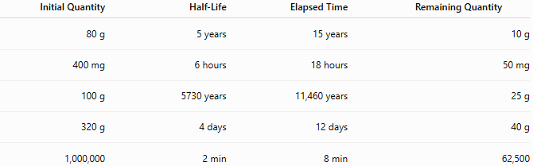
Initial Quantity | Half-Life | Elapsed Time | Remaining Quantity
80 g | 5 years | 15 years | 10 g
400 mg | 6 hours | 18 hours | 50 mg
100 g | 5730 years | 11,460 years | 25 g
320 g | 4 days | 12 days | 40 g
1,000,000 | 2 min | 8 min | 62,500

Applications
# Source: AI Source: Provided by: [Data Path: Persons Table -> ID Column: 1, Name_En Column: Motasem Essam] -> From: [ChatGPT] on [7/15/2026]
Half-life is used in:
- Arithmetic
- Algebra
- Chemistry
- Physics
- Biology
- Medicine
- Engineering
- Environmental Science
- Nuclear Science
- Statistics

Real-Life Applications
# Source: AI Source: Provided by: [Data Path: Persons Table -> ID Column: 1, Name_En Column: Motasem Essam] -> From: [ChatGPT] on [7/15/2026]
Half-life is used in:
- Radioactive isotope decay
- Carbon dating
- Nuclear medicine
- Drug elimination
- Medical imaging
- Toxic substance removal
- Environmental contamination studies
- Chemical reactions
- Biological decay
- Particle physics

Real-Life Examples
# Source: AI Source: Provided by: [Data Path: Persons Table -> ID Column: 1, Name_En Column: Motasem Essam] -> From: [ChatGPT] on [7/15/2026]
1. Carbon-14 Dating
Carbon-14 has a half-life of approximately
$$5730$$
years and is used to estimate the age of ancient organic materials.

2. Medical Isotopes
Technetium-99m has a short half-life, making it useful for medical imaging.

3. Medicines
Many medications lose half of their concentration after a specific number of hours.

4. Radioactive Waste
Scientists use half-life to estimate how long radioactive waste remains hazardous.

5. Environmental Pollution
Certain pollutants decay according to half-life models.

6. Nuclear Physics
Half-life predicts how quickly unstable nuclei transform into more stable forms.

Common Mistakes
# Source: AI Source: Provided by: [Data Path: Persons Table -> ID Column: 1, Name_En Column: Motasem Essam] -> From: [ChatGPT] on [7/15/2026]
- Confusing half-life with a 50% decrease from the original value every period (it is always 50% of the current value).
- Using linear subtraction instead of repeated multiplication by 0.5.
- Forgetting to divide elapsed time by the half-life before applying the formula.
- Assuming the quantity eventually becomes exactly zero.
- Confusing half-life with decay rate.

Key Points
# Source: AI Source: Provided by: [Data Path: Persons Table -> ID Column: 1, Name_En Column: Motasem Essam] -> From: [ChatGPT] on [7/15/2026]
- Half-life is a special case of exponential decay.
- The decay factor is always 0.5.
- Every half-life reduces the current quantity by half.
- Half-life measures time, not percentage.
- The decay follows an exponential curve.

Half-Life vs. Decay Rate
# Source: AI Source: Provided by: [Data Path: Persons Table -> ID Column: 1, Name_En Column: Motasem Essam] -> From: [ChatGPT] on [7/15/2026]
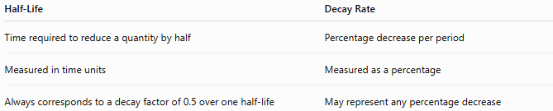
Half-Life | Decay Rate
Time required to reduce a quantity by half | Percentage decrease per period
Measured in time units | Measured as a percentage
Always corresponds to a decay factor of 0.5 over one half-life | May represent any percentage decrease

Half-Life vs. Exponential Decay
# Source: AI Source: Provided by: [Data Path: Persons Table -> ID Column: 1, Name_En Column: Motasem Essam] -> From: [ChatGPT] on [7/15/2026]
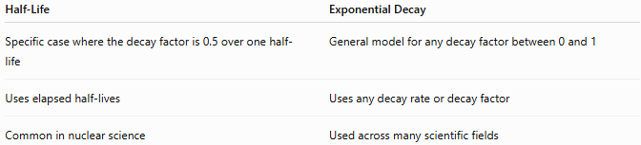
Half-Life | Exponential Decay
Specific case where the decay factor is 0.5 over one half-life | General model for any decay factor between 0 and 1
Uses elapsed half-lives | Uses any decay rate or decay factor
Common in nuclear science | Used across many scientific fields

Half-Life vs. Compound Decay
# Source: AI Source: Provided by: [Data Path: Persons Table -> ID Column: 1, Name_En Column: Motasem Essam] -> From: [ChatGPT] on [7/15/2026]
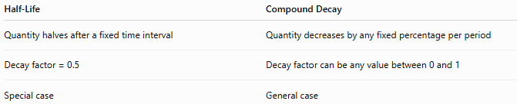
Half-Life | Compound Decay
Quantity halves after a fixed time interval | Quantity decreases by any fixed percentage per period
Decay factor = 0.5 | Decay factor can be any value between 0 and 1
Special case | General case

Conclusion
# Source: AI Source: Provided by: [Data Path: Persons Table -> ID Column: 1, Name_En Column: Motasem Essam] -> From: [ChatGPT] on [7/15/2026]
Half-Life is the time required for a quantity undergoing exponential decay to decrease to one-half of its current value. It is modeled by
$$N=N_{0}{\left(\frac{1}{2}\right)}^{\frac{t}{T_{1/2}}},$$
where $T_{1/2}$is the half-life. Because the remaining quantity is halved after each equal time interval, half-life is a special case of exponential (compound) decay and is widely used in radioactive decay, medicine, chemistry, environmental science, and many other scientific and engineering applications.

Decline Rate
# Source: AI Source: Provided by: [Data Path: Persons Table -> ID Column: 1, Name_En Column: Motasem Essam] -> From: [ChatGPT] on [7/15/2026]
Decline Rate measures the percentage by which a quantity decreases over a specified period. It describes the relative reduction compared with the original value.
Decline rates are widely used in arithmetic, algebra, finance, economics, engineering, business, population studies, biology, computer science, statistics, and many real-world applications.

Definition
# Source: AI Source: Provided by: [Data Path: Persons Table -> ID Column: 1, Name_En Column: Motasem Essam] -> From: [ChatGPT] on [7/15/2026]
A Decline Rate is the percentage decrease of a quantity relative to its original value.
If
- $V_{1}$= original value
- $V_{2}$= new value
where
$$V_{2}<V_{1},$$
then the decline rate is
$$\boxed{\text{Decline Rate}=\frac{V_{1}-V_{2}}{V_{1}}×100\%}$$

Decline Rate Formula
# Source: AI Source: Provided by: [Data Path: Persons Table -> ID Column: 1, Name_En Column: Motasem Essam] -> From: [ChatGPT] on [7/15/2026]
$$\boxed{\text{Decline Rate}=\frac{\text{Decrease}}{\text{Original Value}}×100\%}$$
Since
$$\text{Decrease}=V_{1}-V_{2},$$
the formula becomes
$$\boxed{\text{Decline Rate}=\frac{V_{1}-V_{2}}{V_{1}}×100\%}$$

Finding the New Value
# Source: AI Source: Provided by: [Data Path: Persons Table -> ID Column: 1, Name_En Column: Motasem Essam] -> From: [ChatGPT] on [7/15/2026]
If the decline rate is known,
$$\boxed{V_{2}=V_{1}\left(1 − \frac{r}{100}\right)}$$
where
- $r$= decline rate (%).

Decline Factor
# Source: AI Source: Provided by: [Data Path: Persons Table -> ID Column: 1, Name_En Column: Motasem Essam] -> From: [ChatGPT] on [7/15/2026]
The multiplier used after a decline is called the decline factor (also known as the decay factor).
$$\boxed{\text{Decline Factor}=1-\frac{r}{100}}$$
Examples:
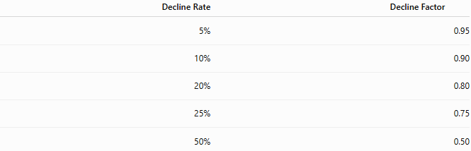
Decline Rate | Decline Factor
5% | 0.95
10% | 0.90
20% | 0.80
25% | 0.75
50% | 0.50

Types of Decline
# Source: AI Source: Provided by: [Data Path: Persons Table -> ID Column: 1, Name_En Column: Motasem Essam] -> From: [ChatGPT] on [7/15/2026]
- Population decline
- Sales decline
- Revenue decline
- Profit decline
- Price decline
- Inventory decline
- Battery capacity decline
- Market share decline
- Production decline
- Resource decline

Examples
# Source: AI Source: Provided by: [Data Path: Persons Table -> ID Column: 1, Name_En Column: Motasem Essam] -> From: [ChatGPT] on [7/15/2026]
Example 1 – Population
Original population:
$$50,000$$
New population:
$$47,500$$
Decline rate:
$$\frac{50,000-47,500}{50,000}×100=5\%$$

Example 2 – Company Sales
Original sales:
$$\$120,000$$
New sales:
$$\$102,000$$
Decline rate:
$$\frac{18,000}{120,000}×100=15\%$$

Example 3 – Stock Price
Original price:
$$\$80$$
New price:
$$\$68$$
Decline rate:
$$\frac{12}{80}×100=15\%$$

Example 4 – Production
Factory output:
$$600$$
to
$$480$$
units.
Decline rate:
$$20\%$$

Example 5 – Website Visitors
Visitors:
$$40,000$$
to
$$34,000.$$
Decline rate:
$$15\%$$

Example 6 – Battery Capacity
Battery capacity:
$$100\%$$
to
$$92\%.$$
Decline rate:
$$8\%$$

Decline Rate Table
# Source: AI Source: Provided by: [Data Path: Persons Table -> ID Column: 1, Name_En Column: Motasem Essam] -> From: [ChatGPT] on [7/15/2026]
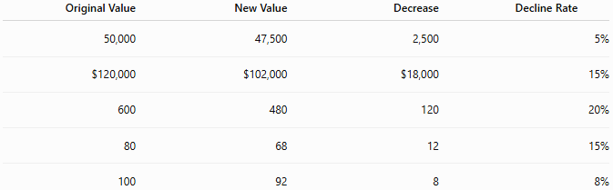
Original Value | New Value | Decrease | Decline Rate
50,000 | 47,500 | 2,500 | 5%
$120,000 | $102,000 | $18,000 | 15%
600 | 480 | 120 | 20%
80 | 68 | 12 | 15%
100 | 92 | 8 | 8%

Applications
# Source: AI Source: Provided by: [Data Path: Persons Table -> ID Column: 1, Name_En Column: Motasem Essam] -> From: [ChatGPT] on [7/15/2026]
Decline rates are used in:
- Arithmetic
- Algebra
- Finance
- Economics
- Statistics
- Business
- Engineering
- Biology
- Computer Science
- Environmental Science

Real-Life Applications
# Source: AI Source: Provided by: [Data Path: Persons Table -> ID Column: 1, Name_En Column: Motasem Essam] -> From: [ChatGPT] on [7/15/2026]
Decline rates are used in:
- Population decline
- Falling sales
- Stock market losses
- Equipment depreciation
- Battery degradation
- Product demand analysis
- Resource depletion
- Manufacturing output
- Market analysis
- Environmental studies

Real-Life Examples
# Source: AI Source: Provided by: [Data Path: Persons Table -> ID Column: 1, Name_En Column: Motasem Essam] -> From: [ChatGPT] on [7/15/2026]
1. Business Revenue
Revenue falls from
$$\$5,000,000$$
to
$$\$4,250,000.$$
Decline rate:
$$15\%$$

2. Population
A town's population decreases from
$$20,000$$
to
$$19,000.$$
Decline rate:
$$5\%$$

3. Stock Price
A stock falls from
$$\$50$$
to
$$\$40.$$
Decline rate:
$$20\%$$

4. Production
Factory production decreases from
$$1000$$
to
$$850$$
units.
Decline rate:
$$15\%$$

5. Battery
Battery health decreases from
$$100\%$$
to
$$94\%.$$
Decline rate:
$$6\%$$

6. Website Traffic
Visitors decrease from
$$80,000$$
to
$$72,000.$$
Decline rate:
$$10\%$$

Common Mistakes
# Source: AI Source: Provided by: [Data Path: Persons Table -> ID Column: 1, Name_En Column: Motasem Essam] -> From: [ChatGPT] on [7/15/2026]
- Dividing by the new value instead of the original value.
- Forgetting to multiply by
$$100\%.$$
- Confusing decline rate with absolute decrease.
- Assuming decline rates are always linear.
- Forgetting that repeated declines require compound (exponential) calculations.

Key Points
# Source: AI Source: Provided by: [Data Path: Persons Table -> ID Column: 1, Name_En Column: Motasem Essam] -> From: [ChatGPT] on [7/15/2026]
- Decline rate measures a relative decrease.
- It is expressed as a percentage.
- It is always calculated using the original value.
- The associated multiplier is the decline factor.
- Repeated decline leads to compound (exponential) decay.

Decline Rate vs. Percentage Decrease
# Source: AI Source: Provided by: [Data Path: Persons Table -> ID Column: 1, Name_En Column: Motasem Essam] -> From: [ChatGPT] on [7/15/2026]
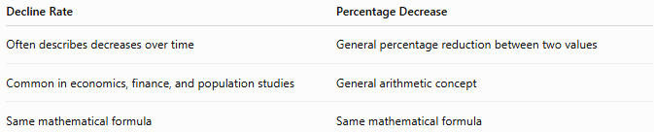
Decline Rate | Percentage Decrease
Often describes decreases over time | General percentage reduction between two values
Common in economics, finance, and population studies | General arithmetic concept
Same mathematical formula | Same mathematical formula

Decline Rate vs. Growth Rate
# Source: AI Source: Provided by: [Data Path: Persons Table -> ID Column: 1, Name_En Column: Motasem Essam] -> From: [ChatGPT] on [7/15/2026]
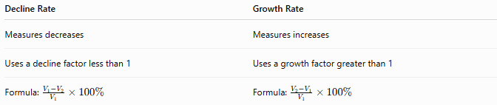
Decline Rate | Growth Rate
Measures decreases | Measures increases
Uses a decline factor less than 1 | Uses a growth factor greater than 1
Formula: $\frac{V_{1}-V_{2}}{V_{1}}×100\%$ | Formula: $\frac{V_{2}-V_{1}}{V_{1}}×100\%$

Decline Rate vs. Decay Rate
# Source: AI Source: Provided by: [Data Path: Persons Table -> ID Column: 1, Name_En Column: Motasem Essam] -> From: [ChatGPT] on [7/15/2026]
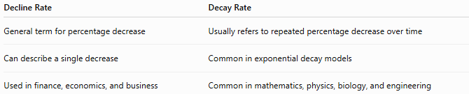
Decline Rate | Decay Rate
General term for percentage decrease | Usually refers to repeated percentage decrease over time
Can describe a single decrease | Common in exponential decay models
Used in finance, economics, and business | Common in mathematics, physics, biology, and engineering

Decline Rate vs. Absolute Change
# Source: AI Source: Provided by: [Data Path: Persons Table -> ID Column: 1, Name_En Column: Motasem Essam] -> From: [ChatGPT] on [7/15/2026]
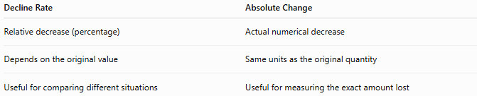
Decline Rate | Absolute Change
Relative decrease (percentage) | Actual numerical decrease
Depends on the original value | Same units as the original quantity
Useful for comparing different situations | Useful for measuring the exact amount lost

Conclusion
# Source: AI Source: Provided by: [Data Path: Persons Table -> ID Column: 1, Name_En Column: Motasem Essam] -> From: [ChatGPT] on [7/15/2026]
A Decline Rate measures the percentage by which a quantity decreases relative to its original value. It is calculated by
$$\frac{V_{1}-V_{2}}{V_{1}}×100\%,$$
and represents the relative reduction in a quantity over a specified period. The corresponding decline factor is
$$1-\frac{r}{100},$$
which is used to calculate the new value after a decline. Decline rates are fundamental in mathematics and are widely applied in economics, finance, business, engineering, population studies, and many scientific disciplines to analyze and model decreasing quantities.

Decline Factor
# Source: AI Source: Provided by: [Data Path: Persons Table -> ID Column: 1, Name_En Column: Motasem Essam] -> From: [ChatGPT] on [7/15/2026]
A Decline Factor is a multiplier that represents how much of a quantity remains after a decline. Instead of working directly with a percentage decrease, the decline factor provides a convenient way to calculate the new value after a decline.
The terms Decline Factor and Decay Factor are often used interchangeably. In mathematics and science, Decay Factor is more common, while Decline Factor is frequently used in business, economics, finance, and population studies.

Definition
# Source: AI Source: Provided by: [Data Path: Persons Table -> ID Column: 1, Name_En Column: Motasem Essam] -> From: [ChatGPT] on [7/15/2026]
A Decline Factor is the number by which the original value is multiplied to obtain the new value after a decline.
If the decline rate is
$$r\%$$
then the decline factor is
$$\boxed{1-\frac{r}{100}}$$

Decline Factor Formula
# Source: AI Source: Provided by: [Data Path: Persons Table -> ID Column: 1, Name_En Column: Motasem Essam] -> From: [ChatGPT] on [7/15/2026]
$$\boxed{\text{Decline Factor}=1-\frac{r}{100}}$$
where
- $r$= decline rate (%).

New Value Formula
# Source: AI Source: Provided by: [Data Path: Persons Table -> ID Column: 1, Name_En Column: Motasem Essam] -> From: [ChatGPT] on [7/15/2026]
Once the decline factor is known,
$$\boxed{\text{New Value}=\text{Original Value}×\text{Decline Factor}}$$
or
$$\boxed{V_{2}=V_{1}\left(1 − \frac{r}{100}\right)}$$

Finding the Decline Rate from the Decline Factor
# Source: AI Source: Provided by: [Data Path: Persons Table -> ID Column: 1, Name_En Column: Motasem Essam] -> From: [ChatGPT] on [7/15/2026]
If the decline factor is known,
$$\boxed{\text{Decline Rate}=(1-\text{Decline Factor})×100\%}$$

Decline Factor Table
# Source: AI Source: Provided by: [Data Path: Persons Table -> ID Column: 1, Name_En Column: Motasem Essam] -> From: [ChatGPT] on [7/15/2026]
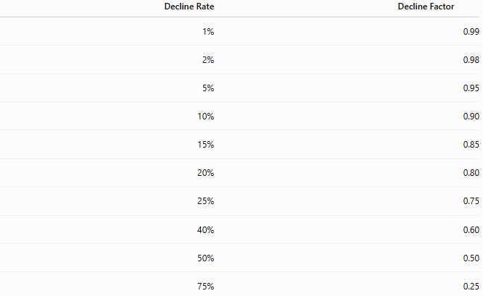
Decline Rate | Decline Factor
1% | 0.99
2% | 0.98
5% | 0.95
10% | 0.90
15% | 0.85
20% | 0.80
25% | 0.75
40% | 0.60
50% | 0.50
75% | 0.25

Examples
# Source: AI Source: Provided by: [Data Path: Persons Table -> ID Column: 1, Name_En Column: Motasem Essam] -> From: [ChatGPT] on [7/15/2026]
Example 1 – Product Price
Original price:
$$\$500$$
Decline rate:
$$20\%$$
Decline factor:
$$1-\frac{20}{100}=0.80$$
New price:
$$500×0.80=400$$

Example 2 – Population
Population:
$$50,000$$
Decline rate:
$$4\%$$
Decline factor:
$$0.96$$
New population:
$$50,000×0.96=48,000$$

Example 3 – Company Revenue
Revenue:
$$\$250,000$$
Decline rate:
$$12\%$$
Decline factor:
$$0.88$$
New revenue:
$$220,000$$

Example 4 – Inventory
Inventory:
$$800$$
units
Decline rate:
$$15\%$$
Decline factor:
$$0.85$$
Remaining inventory:
$$680$$
units

Example 5 – Battery Capacity
Battery capacity:
$$100\%$$
Decline rate:
$$8\%$$
Decline factor:
$$0.92$$
Remaining capacity:
$$92\%$$

Example 6 – Website Visitors
Visitors:
$$10,000$$
Decline rate:
$$25\%$$
Decline factor:
$$0.75$$
Remaining visitors:
$$7,500$$

Decline Factor Table with Calculations
# Source: AI Source: Provided by: [Data Path: Persons Table -> ID Column: 1, Name_En Column: Motasem Essam] -> From: [ChatGPT] on [7/15/2026]
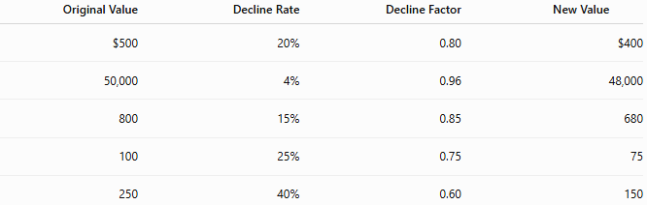
Original Value | Decline Rate | Decline Factor | New Value
$500 | 20% | 0.80 | $400
50,000 | 4% | 0.96 | 48,000
800 | 15% | 0.85 | 680
100 | 25% | 0.75 | 75
250 | 40% | 0.60 | 150

Multiple Decline Periods
# Source: AI Source: Provided by: [Data Path: Persons Table -> ID Column: 1, Name_En Column: Motasem Essam] -> From: [ChatGPT] on [7/15/2026]
If decline occurs repeatedly over
$$n$$
periods,
$$\boxed{V=V_{0}(\text{Decline Factor})^{n}}$$
or
$$\boxed{V=V_{0}{\left(1 − \frac{r}{100}\right)}^{n}}$$
This models compound (exponential) decline.

Example
Initial investment:
$$\$1000$$
Annual decline:
$$5\%$$
Decline factor:
$$0.95$$
After
3
years:
$$1000(0.95)^{3}=857.38$$

Applications
# Source: AI Source: Provided by: [Data Path: Persons Table -> ID Column: 1, Name_En Column: Motasem Essam] -> From: [ChatGPT] on [7/15/2026]
Decline factors are used in:
- Arithmetic
- Algebra
- Finance
- Economics
- Engineering
- Statistics
- Biology
- Computer Science
- Population Studies
- Environmental Science

Real-Life Applications
# Source: AI Source: Provided by: [Data Path: Persons Table -> ID Column: 1, Name_En Column: Motasem Essam] -> From: [ChatGPT] on [7/15/2026]
Decline factors are used in:
- Product depreciation
- Equipment wear
- Population decline
- Business revenue forecasting
- Inventory reduction
- Battery degradation
- Radioactive decay
- Environmental resource depletion
- Market contraction
- Financial loss modeling

Real-Life Examples
# Source: AI Source: Provided by: [Data Path: Persons Table -> ID Column: 1, Name_En Column: Motasem Essam] -> From: [ChatGPT] on [7/15/2026]
1. Vehicle Value
A vehicle loses
10%
of its value each year.
Decline factor:
$$0.90$$

2. Population
Population decreases
3%
annually.
Decline factor:
$$0.97$$

3. Company Sales
Sales decline
15%
each year.
Decline factor:
$$0.85$$

4. Battery Health
Battery health decreases
5%
each year.
Decline factor:
$$0.95$$

5. Inventory
Inventory shrinks
20%
every month.
Decline factor:
$$0.80$$

6. Forest Area
Forest area declines
2%
per year.
Decline factor:
$$0.98$$

Common Mistakes
# Source: AI Source: Provided by: [Data Path: Persons Table -> ID Column: 1, Name_En Column: Motasem Essam] -> From: [ChatGPT] on [7/15/2026]
- Using
$$0.20$$
instead of
$$0.80.$$
- Forgetting to subtract the percentage from
$$1.$$
- Confusing the decline factor with the decline rate.
- Adding the decline percentage after multiplication instead of using the decline factor.
- Using a decline factor greater than 1 (which represents growth, not decline).

Key Points
# Source: AI Source: Provided by: [Data Path: Persons Table -> ID Column: 1, Name_En Column: Motasem Essam] -> From: [ChatGPT] on [7/15/2026]
- A decline factor is a multiplier.
- It is always between 0 and 1 for a positive decline.
- Multiply the original value by the decline factor to obtain the new value.
- Repeated decline uses exponents.
- Decline factors simplify repeated calculations.

Decline Factor vs. Decline Rate
# Source: AI Source: Provided by: [Data Path: Persons Table -> ID Column: 1, Name_En Column: Motasem Essam] -> From: [ChatGPT] on [7/15/2026]
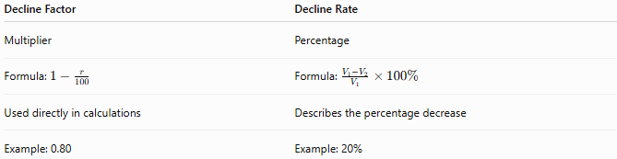
Decline Factor | Decline Rate
Multiplier | Percentage
Formula: $1-\frac{r}{100}$ | Formula: $\frac{V_{1}-V_{2}}{V_{1}}×100\%$
Used directly in calculations | Describes the percentage decrease
Example: 0.80 | Example: 20%

Decline Factor vs. Decay Factor
# Source: AI Source: Provided by: [Data Path: Persons Table -> ID Column: 1, Name_En Column: Motasem Essam] -> From: [ChatGPT] on [7/15/2026]
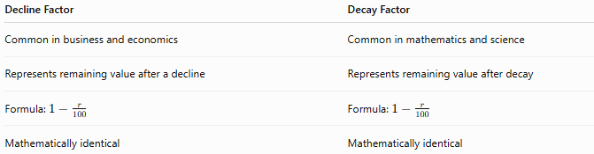
Decline Factor | Decay Factor
Common in business and economics | Common in mathematics and science
Represents remaining value after a decline | Represents remaining value after decay
Formula: $1-\frac{r}{100}$ | Formula: $1-\frac{r}{100}$
Mathematically identical | Mathematically identical

Decline Factor vs. Growth Factor
# Source: AI Source: Provided by: [Data Path: Persons Table -> ID Column: 1, Name_En Column: Motasem Essam] -> From: [ChatGPT] on [7/15/2026]
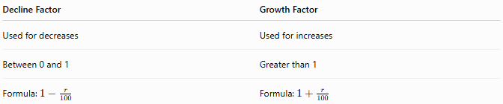
Decline Factor | Growth Factor
Used for decreases | Used for increases
Between 0 and 1 | Greater than 1
Formula: $1-\frac{r}{100}$ | Formula: $1+\frac{r}{100}$

Decline Factor vs. Compound Decay
# Source: AI Source: Provided by: [Data Path: Persons Table -> ID Column: 1, Name_En Column: Motasem Essam] -> From: [ChatGPT] on [7/15/2026]
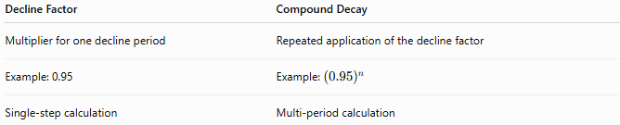
Decline Factor | Compound Decay
Multiplier for one decline period | Repeated application of the decline factor
Example: 0.95 | Example: ${\left(0.95\right)}^{n}$
Single-step calculation | Multi-period calculation

Conclusion
# Source: AI Source: Provided by: [Data Path: Persons Table -> ID Column: 1, Name_En Column: Motasem Essam] -> From: [ChatGPT] on [7/15/2026]
A Decline Factor is the multiplier used to calculate the remaining value of a quantity after a decline. It is computed by
$$1-\frac{r}{100},$$
where $r$is the decline rate expressed as a percentage. The new value is found by multiplying the original value by the decline factor, and repeated declines are modeled by raising the decline factor to a power. Decline factors are fundamental in mathematics and are widely used in finance, economics, engineering, business, population studies, and scientific modeling because they provide a simple and efficient way to represent and calculate decreases over time.

